[GROUP 04]
Tutorials
GAME PROJECTS

Contents

DEVELOPMENT STACK 2
Unreal Engine 2
Installation 2
Source Code 5
Creating a C++ Project 7
Opening a C++ Project 14
Plugins 19
IDE 21
Visual Studio 21
Rider 28
Perforce 31
Excluding Trees 31
Locking binary documents 37
Submitting deleted files 39

DEVELOPMENT STACK

Unreal Engine

Installation
During installation, do not modify the drive or the installation path.
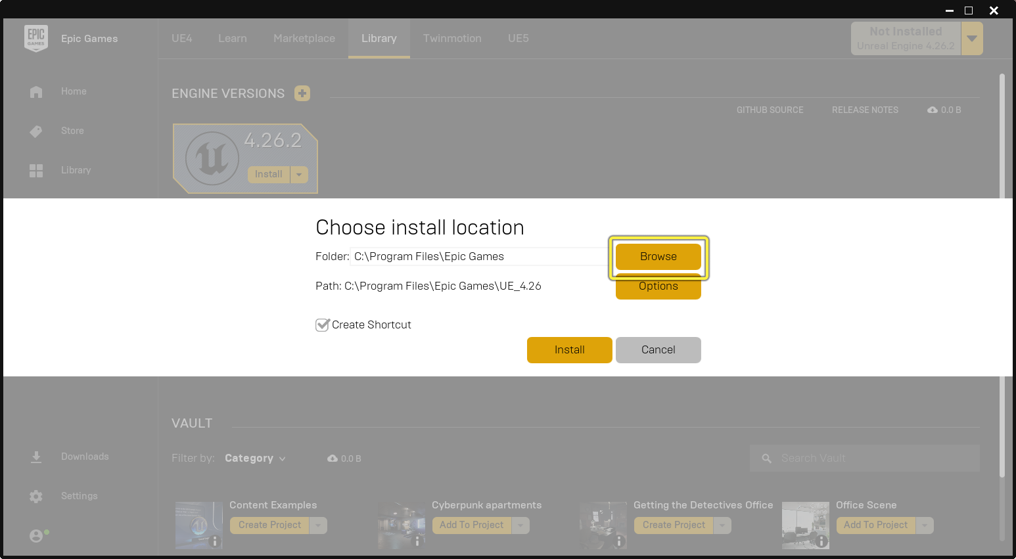
Apart from Core Components (required), ensure that the first three optional selections are enabled for everyone.
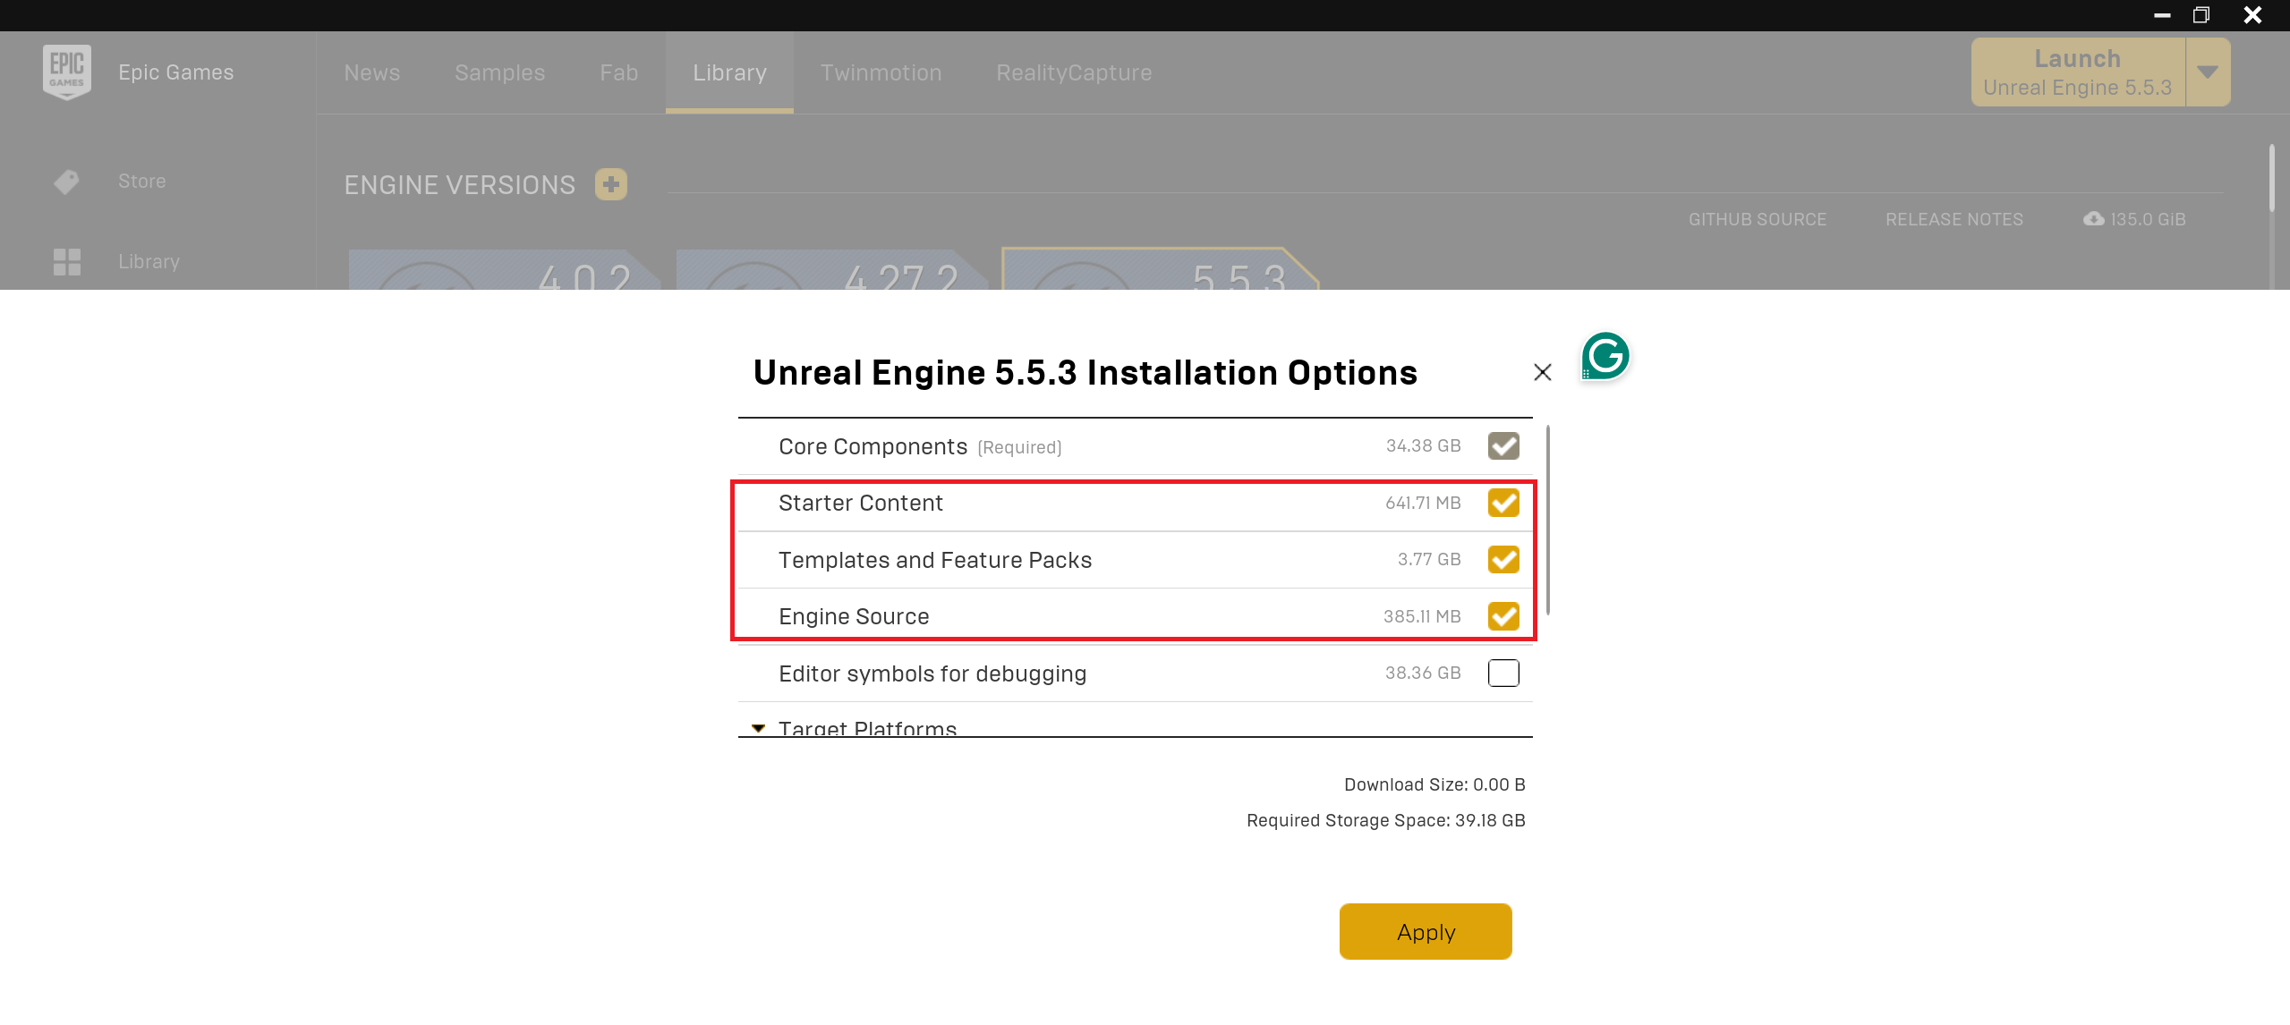
For developers, selecting Editor symbols for debugging is mandatory.
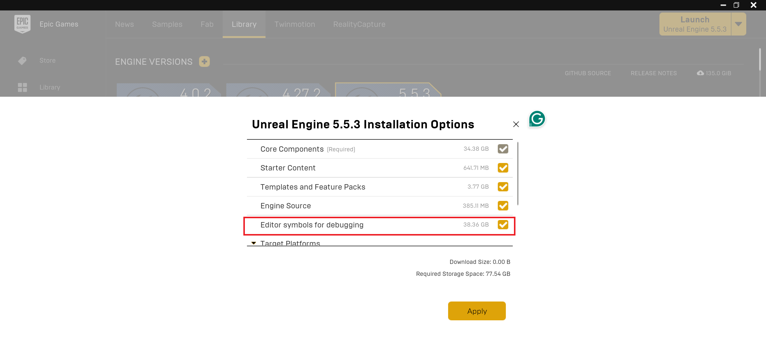
Since our target platform is Windows, there is no need to install additional components - Target Platforms can be left unchecked.
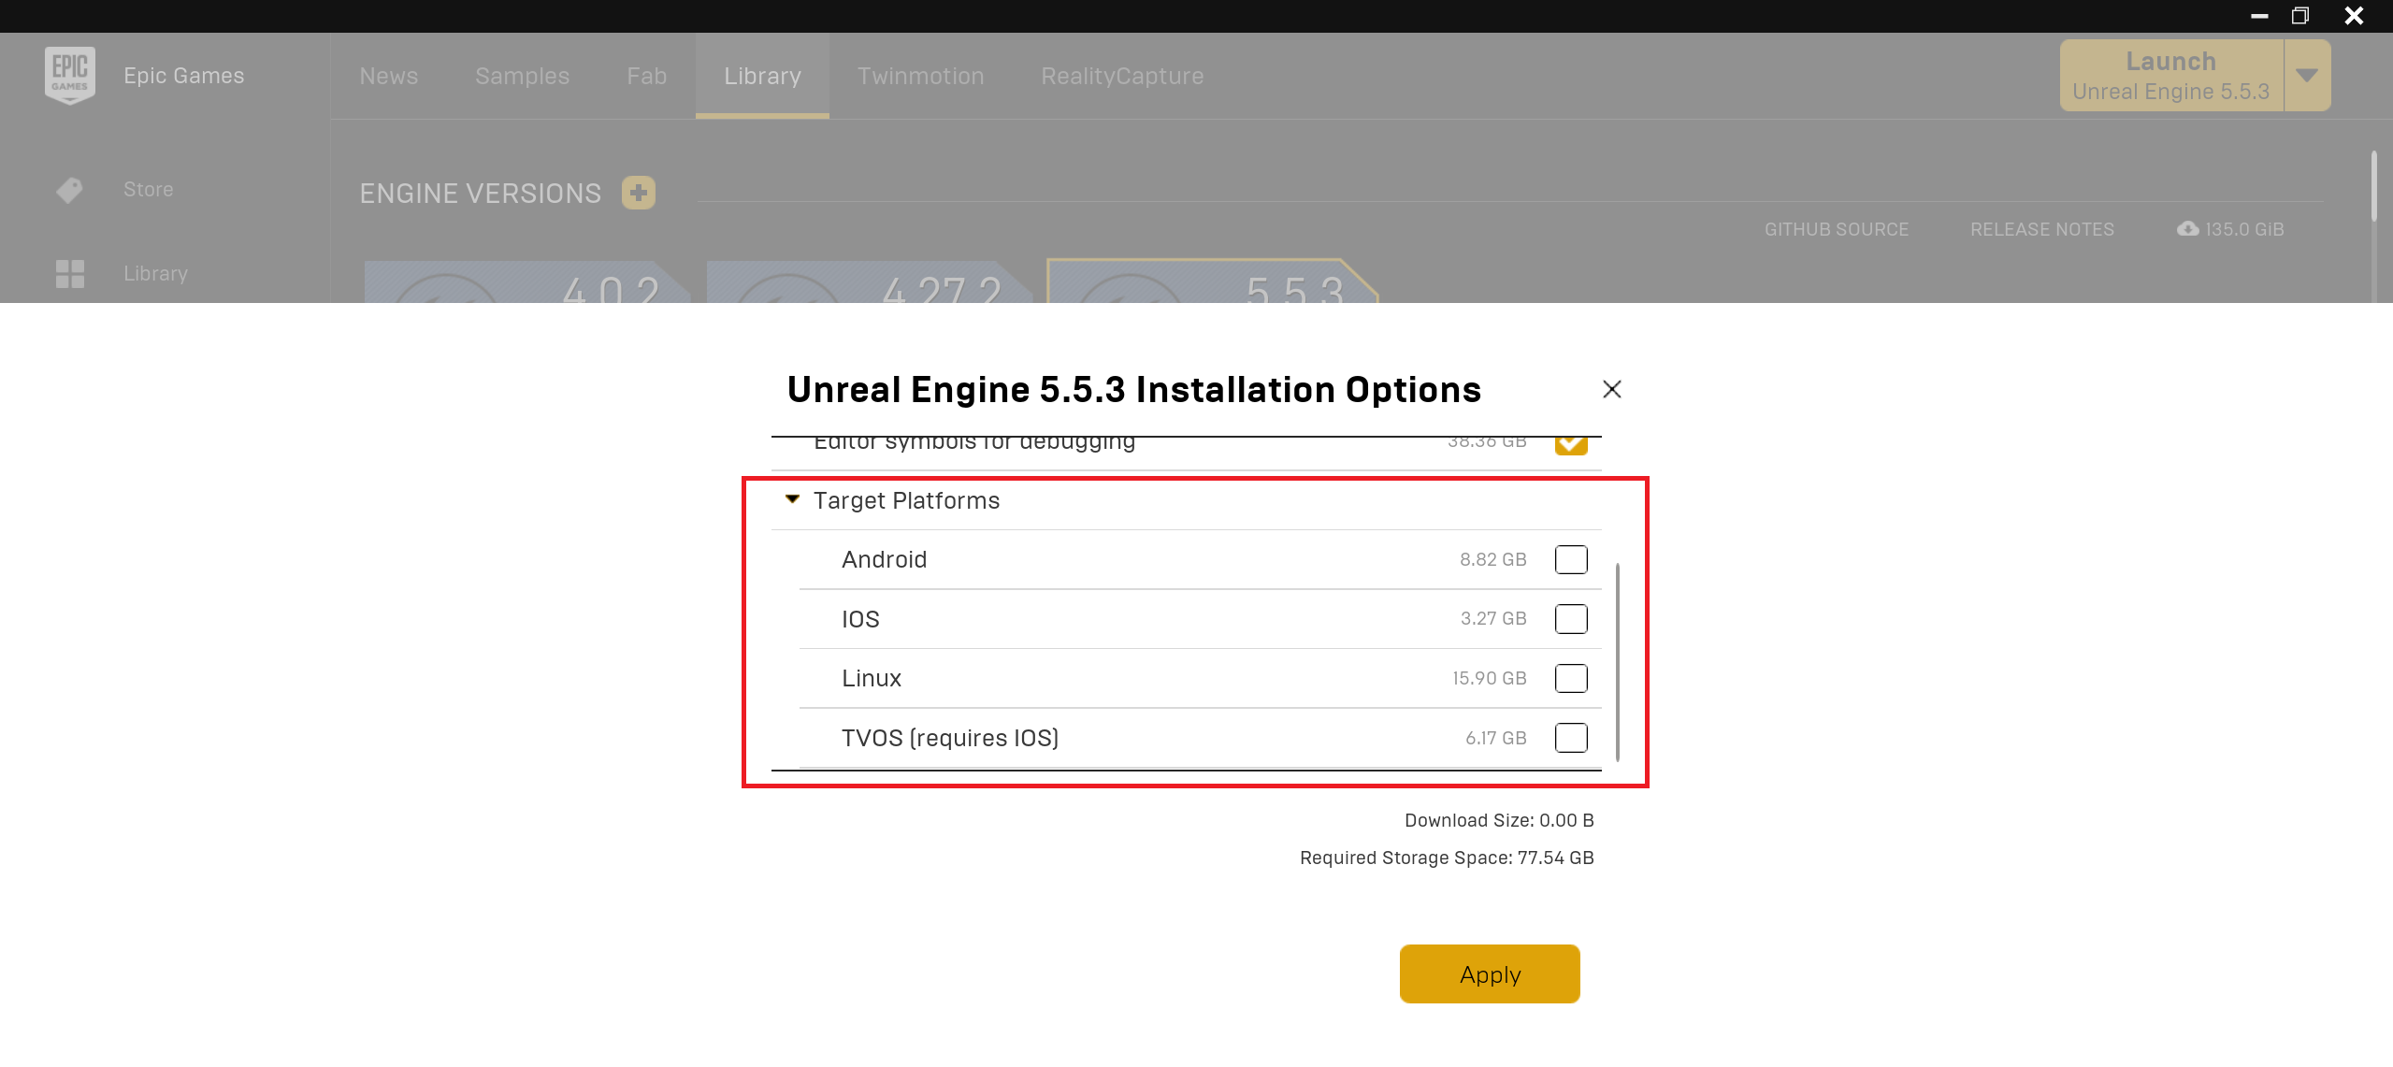

Verification
In certain cases, the engine may not function properly, for instance, if an internet connection is lost during a hotfix installation or if engine files become corrupted. In such situations, it is advisable to verify the integrity of the engine's content. This can be done as follows:
- In the Epic Games Launcher, click on the arrow button. 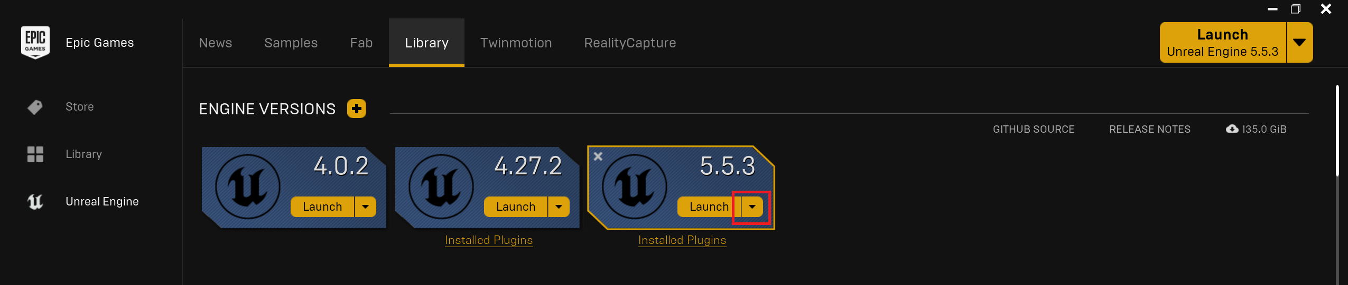
- In the dropdown menu, select the Verify option.
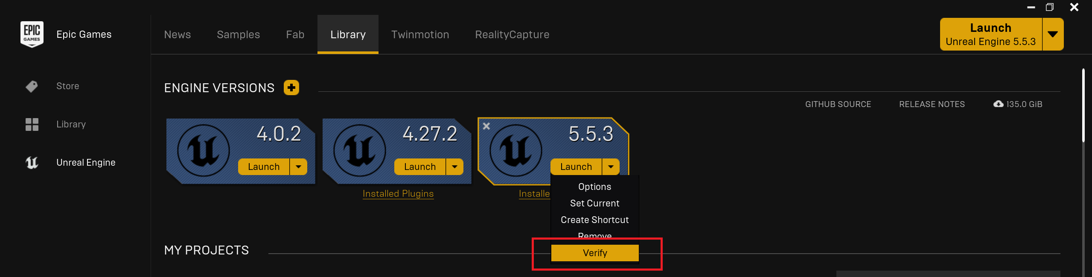
- The process may take anywhere from 5 to 15 minutes. 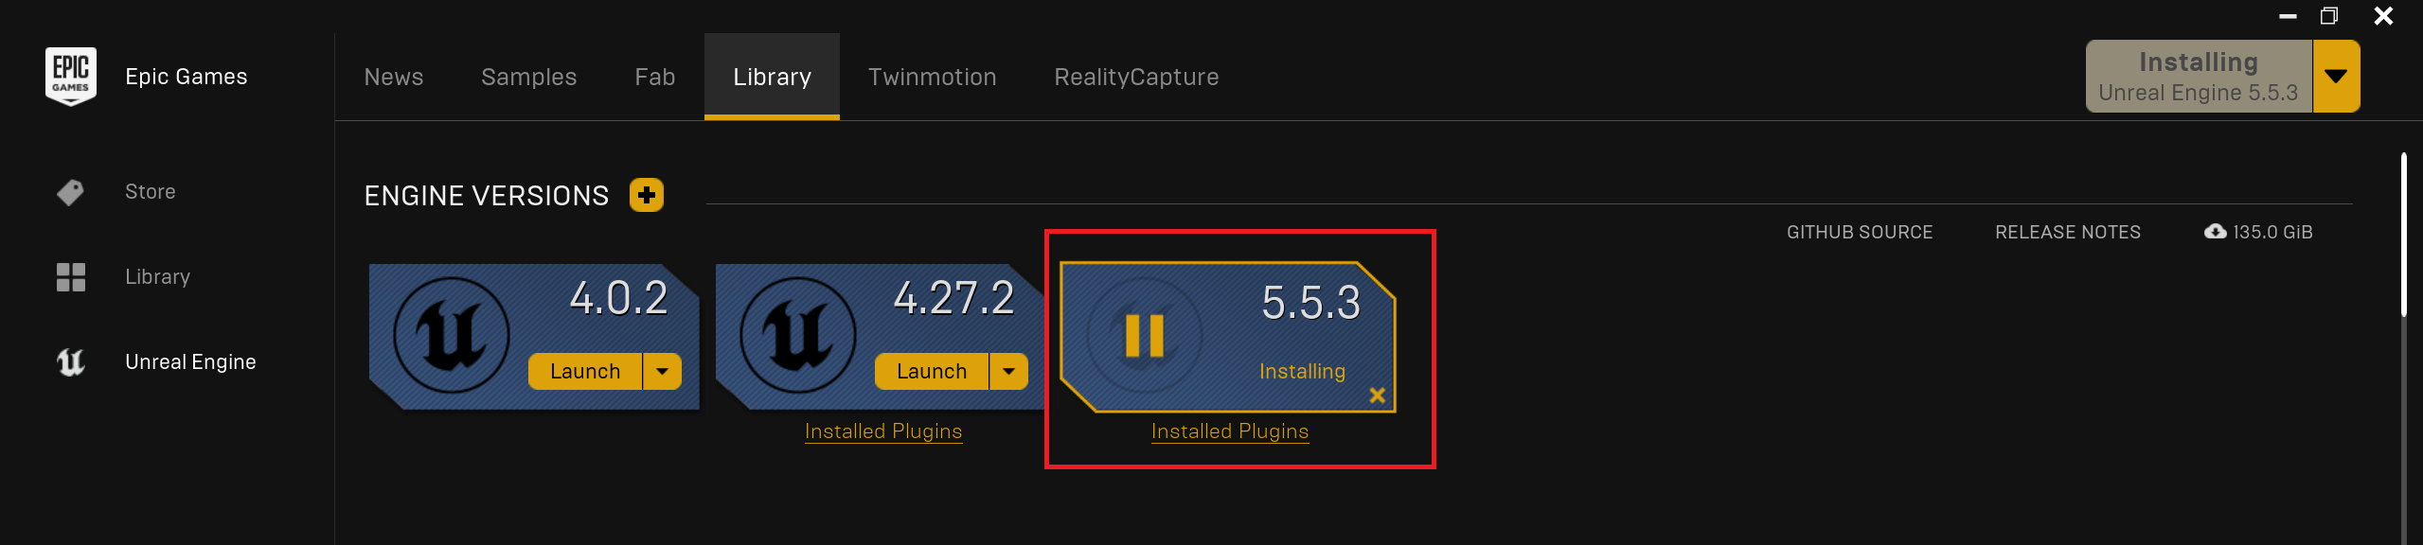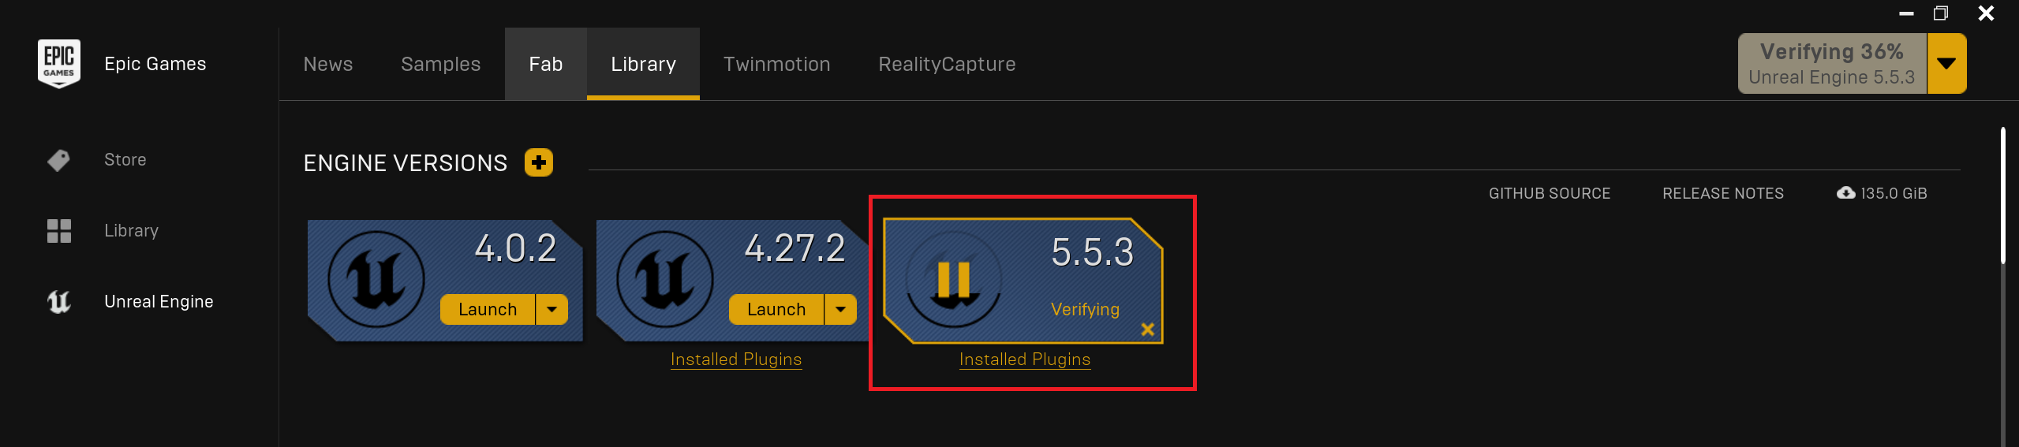
- Once the process is complete, verify its success by launching the engine.
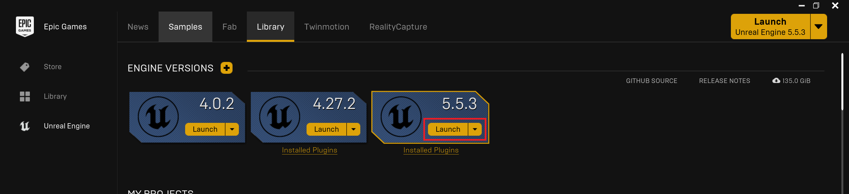

Source Code
After successfully installing our chosen IDE, ensure that the settings within Unreal Engine are configured correctly.
- Open the project, then navigate to Editor Preferences….
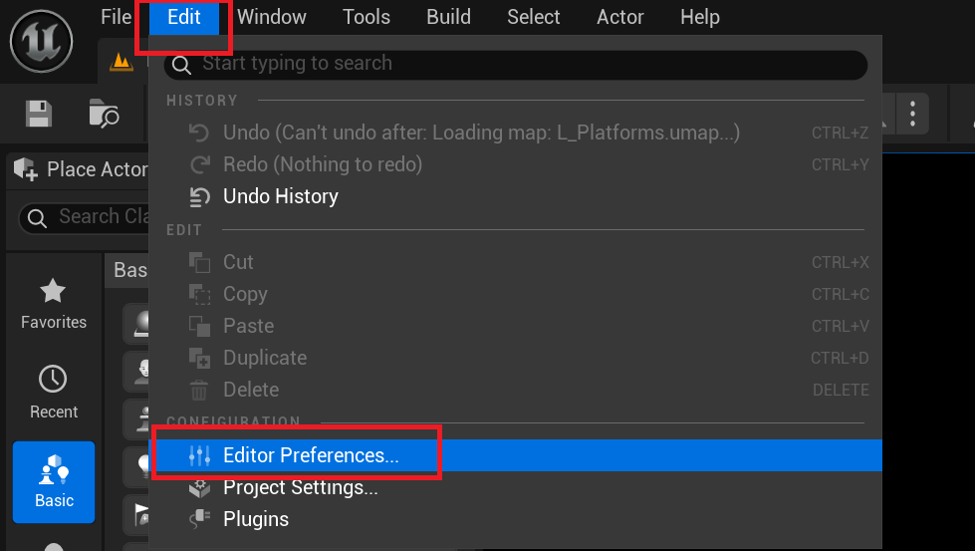
- In the Source Code submenu, select the desired code editor - either Visual Studio or Rider in our case.
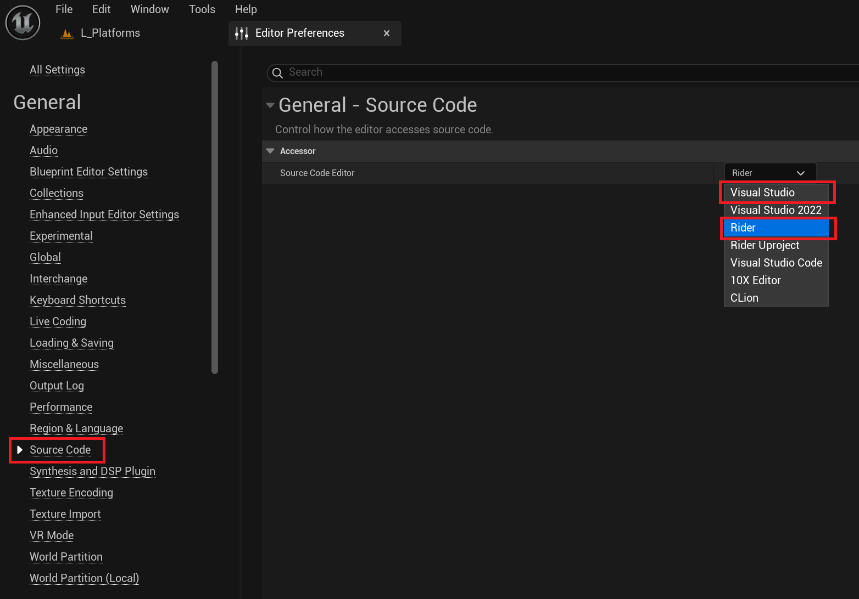

Creating a C++ Project
To ensure that Unreal Engine is functioning correctly, we will create a simple C++ test project following the steps below.
- Launch Unreal Engine.
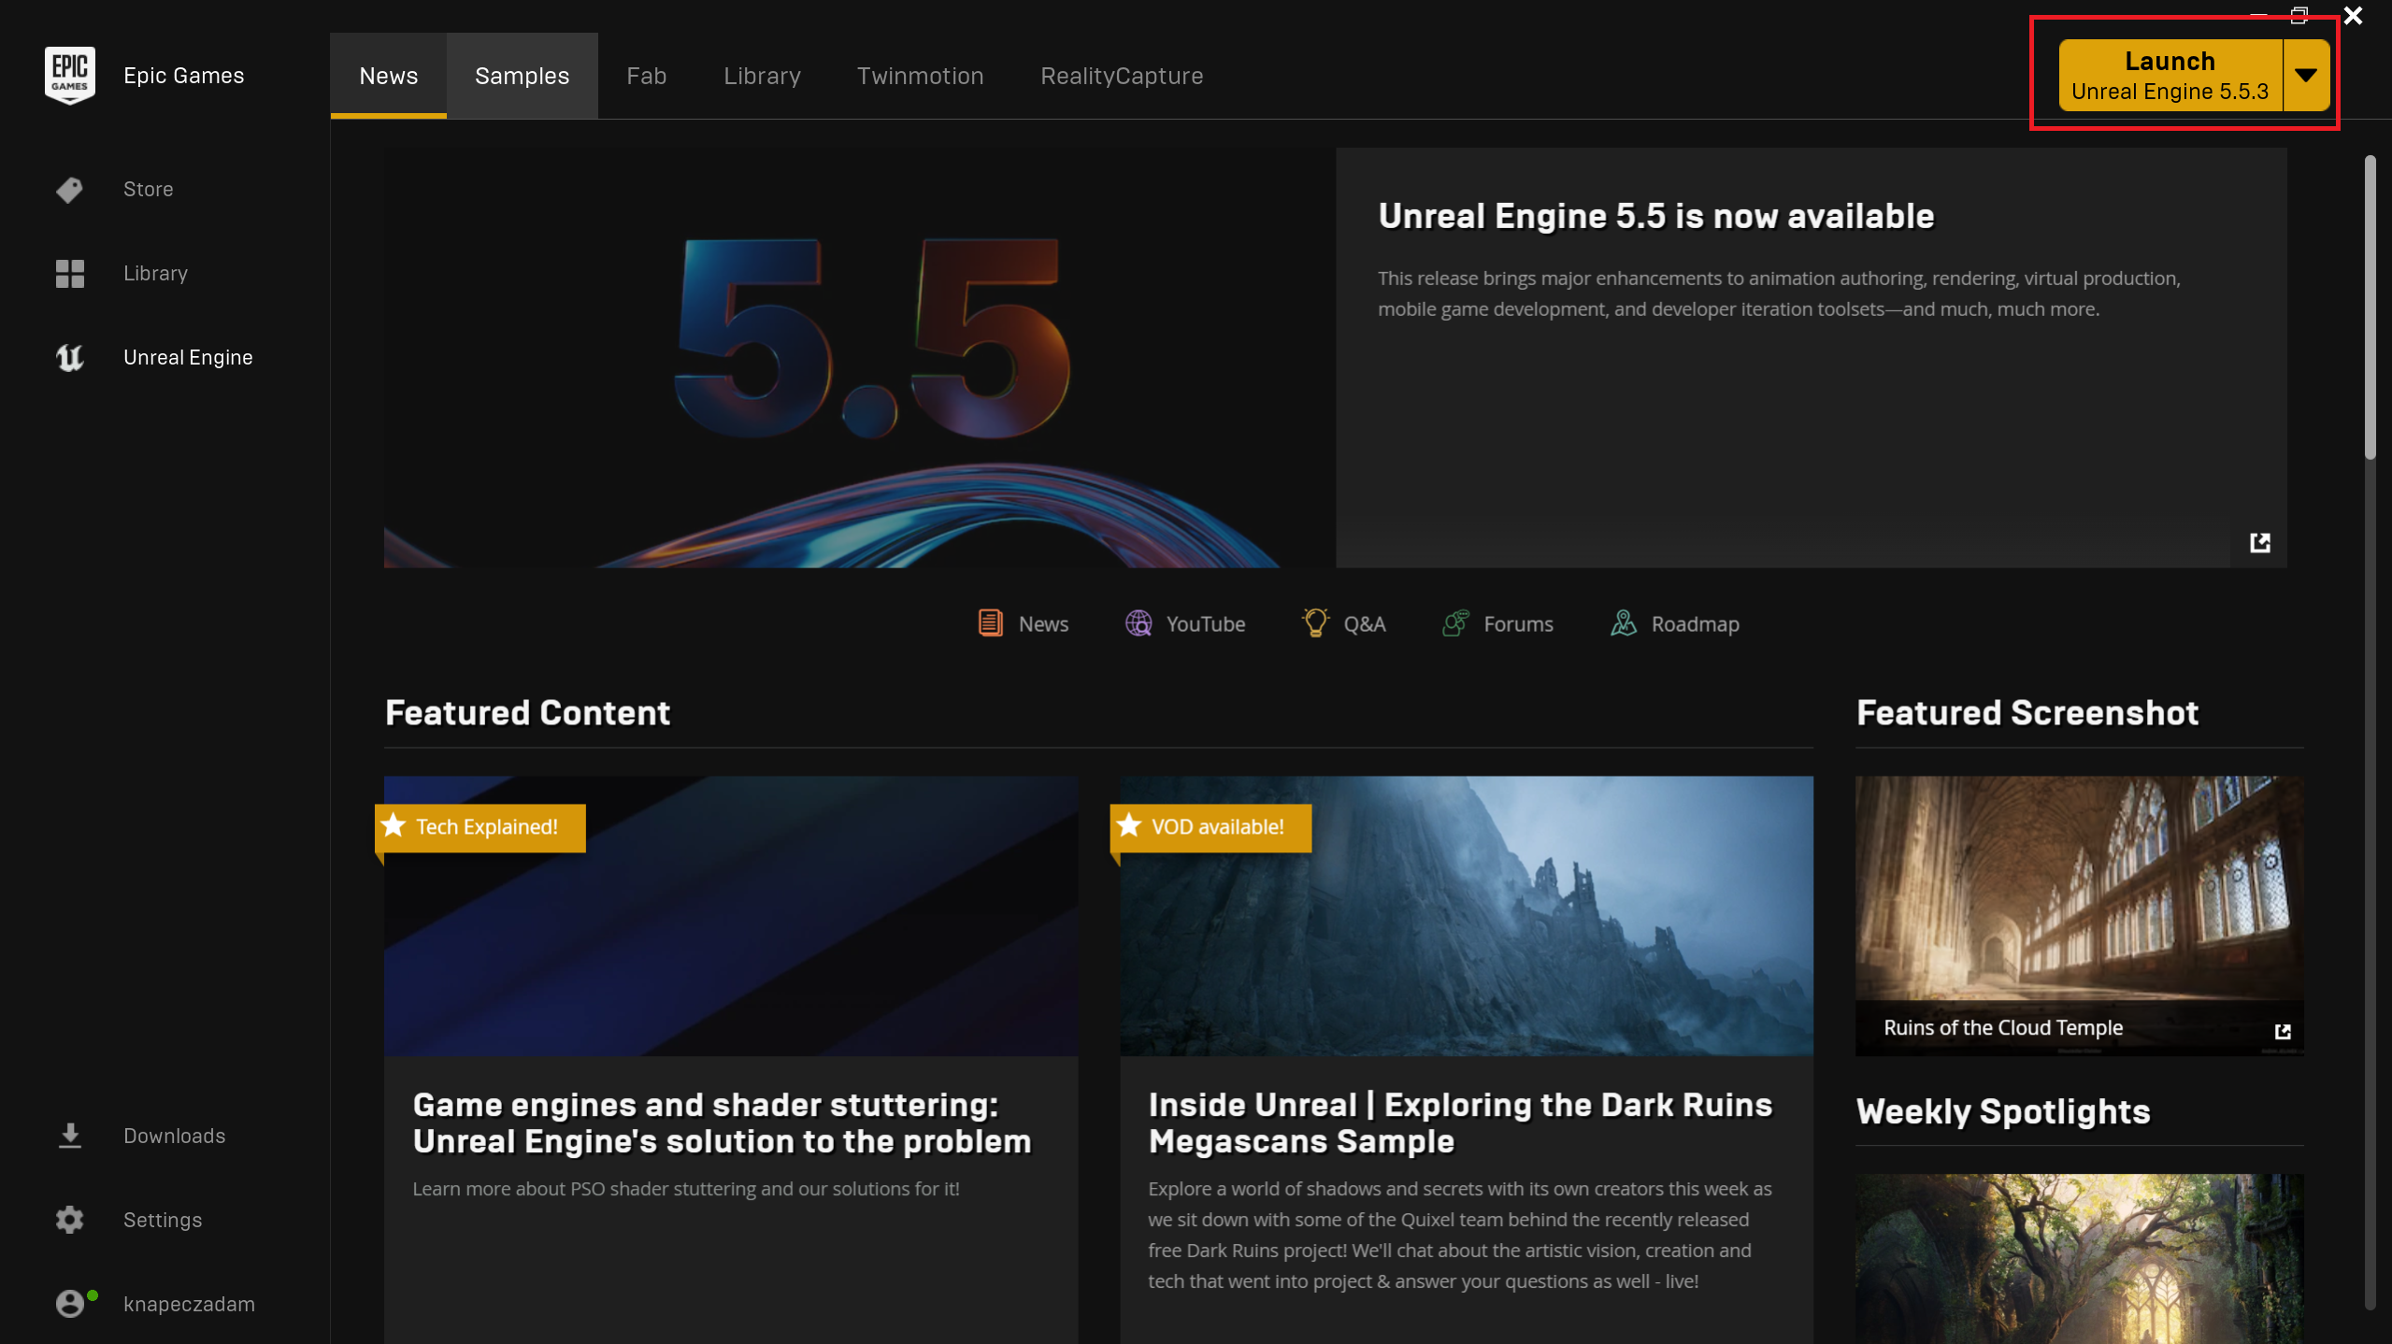
- Click on the GAMES tab, select the Third Person template, then on the right side, switch to the C++ tab. Finally, specify a desired project name and file path. Click on Create.
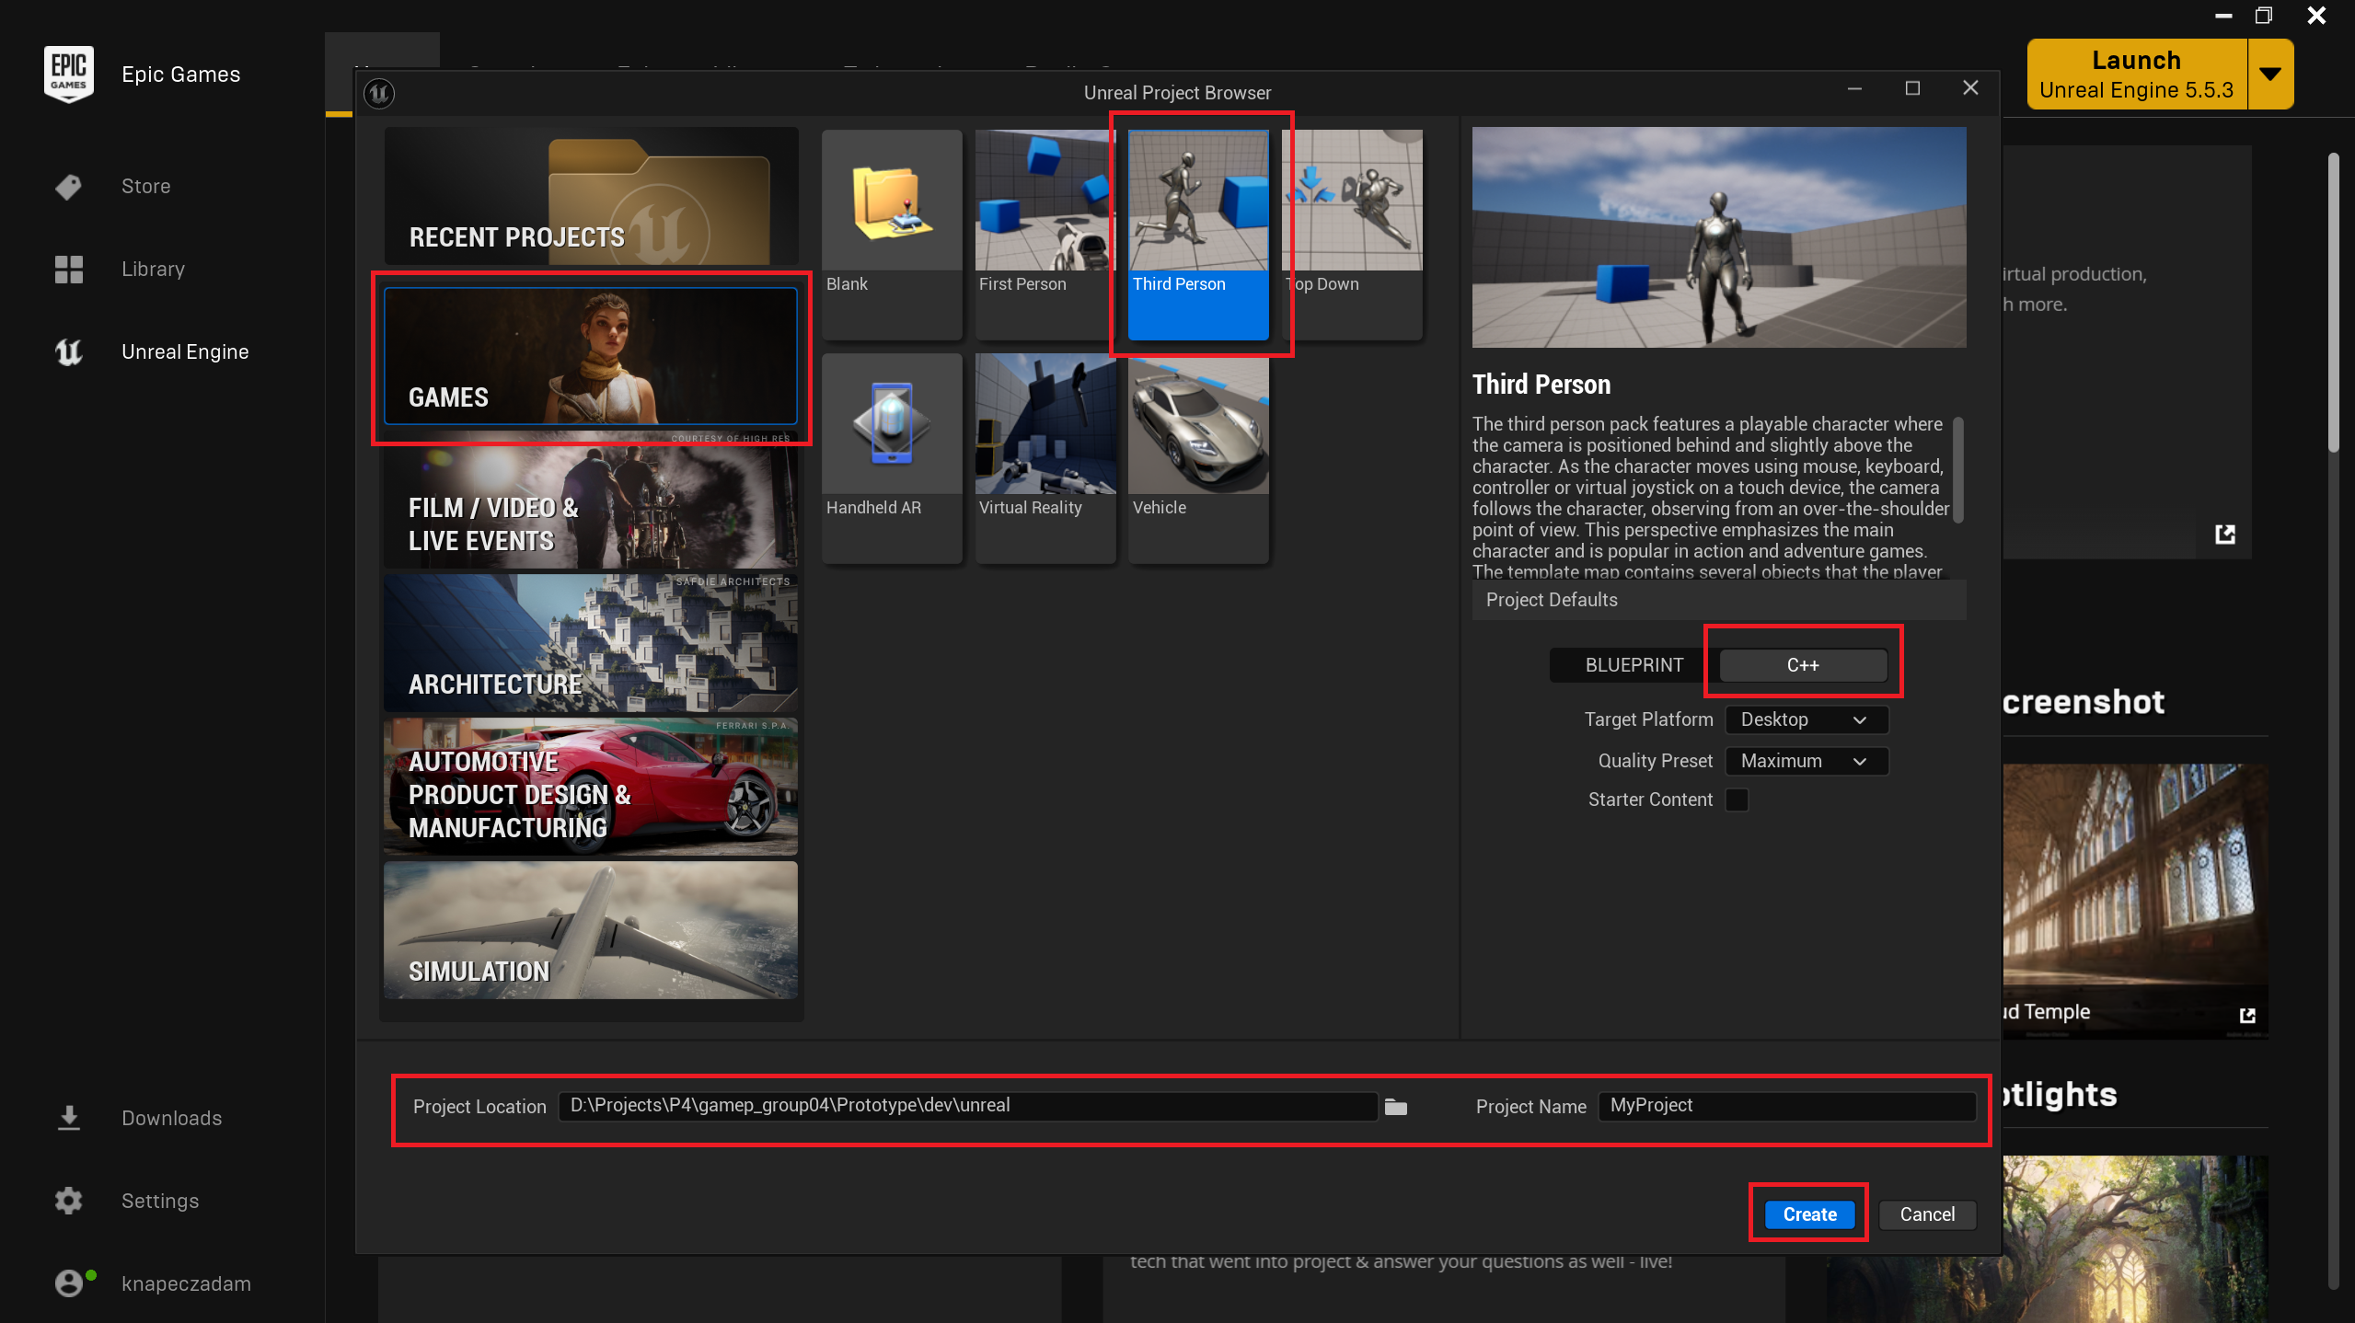
- Project creation in progress...
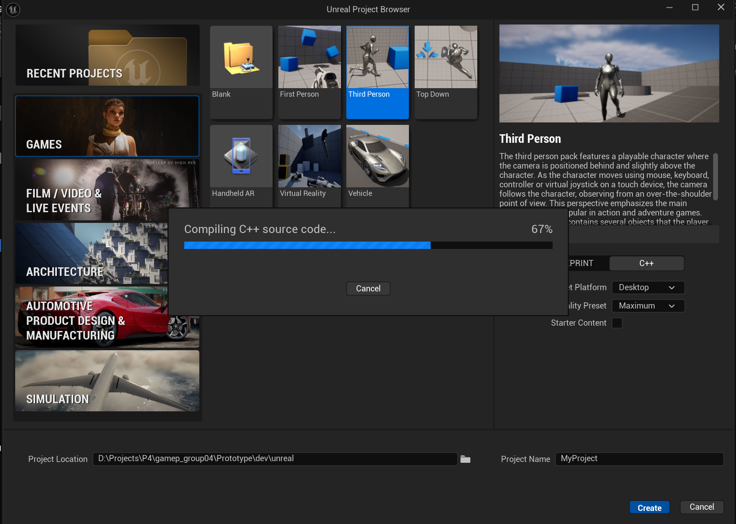
- If the compilation is successful, both Unreal Engine and the default code editor will open automatically. This example demonstrates the process using Rider IDE.
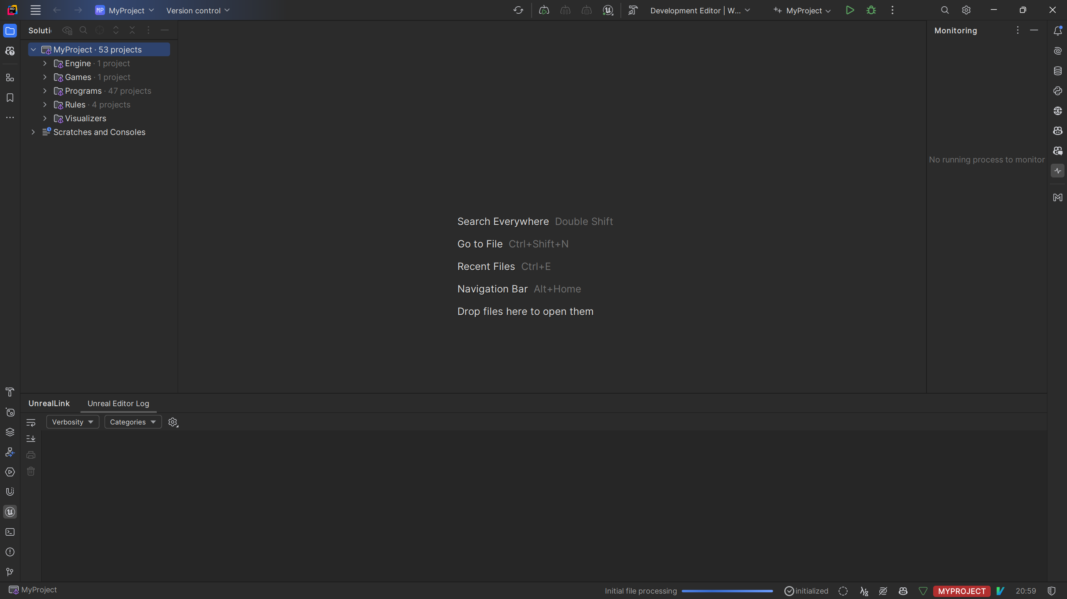
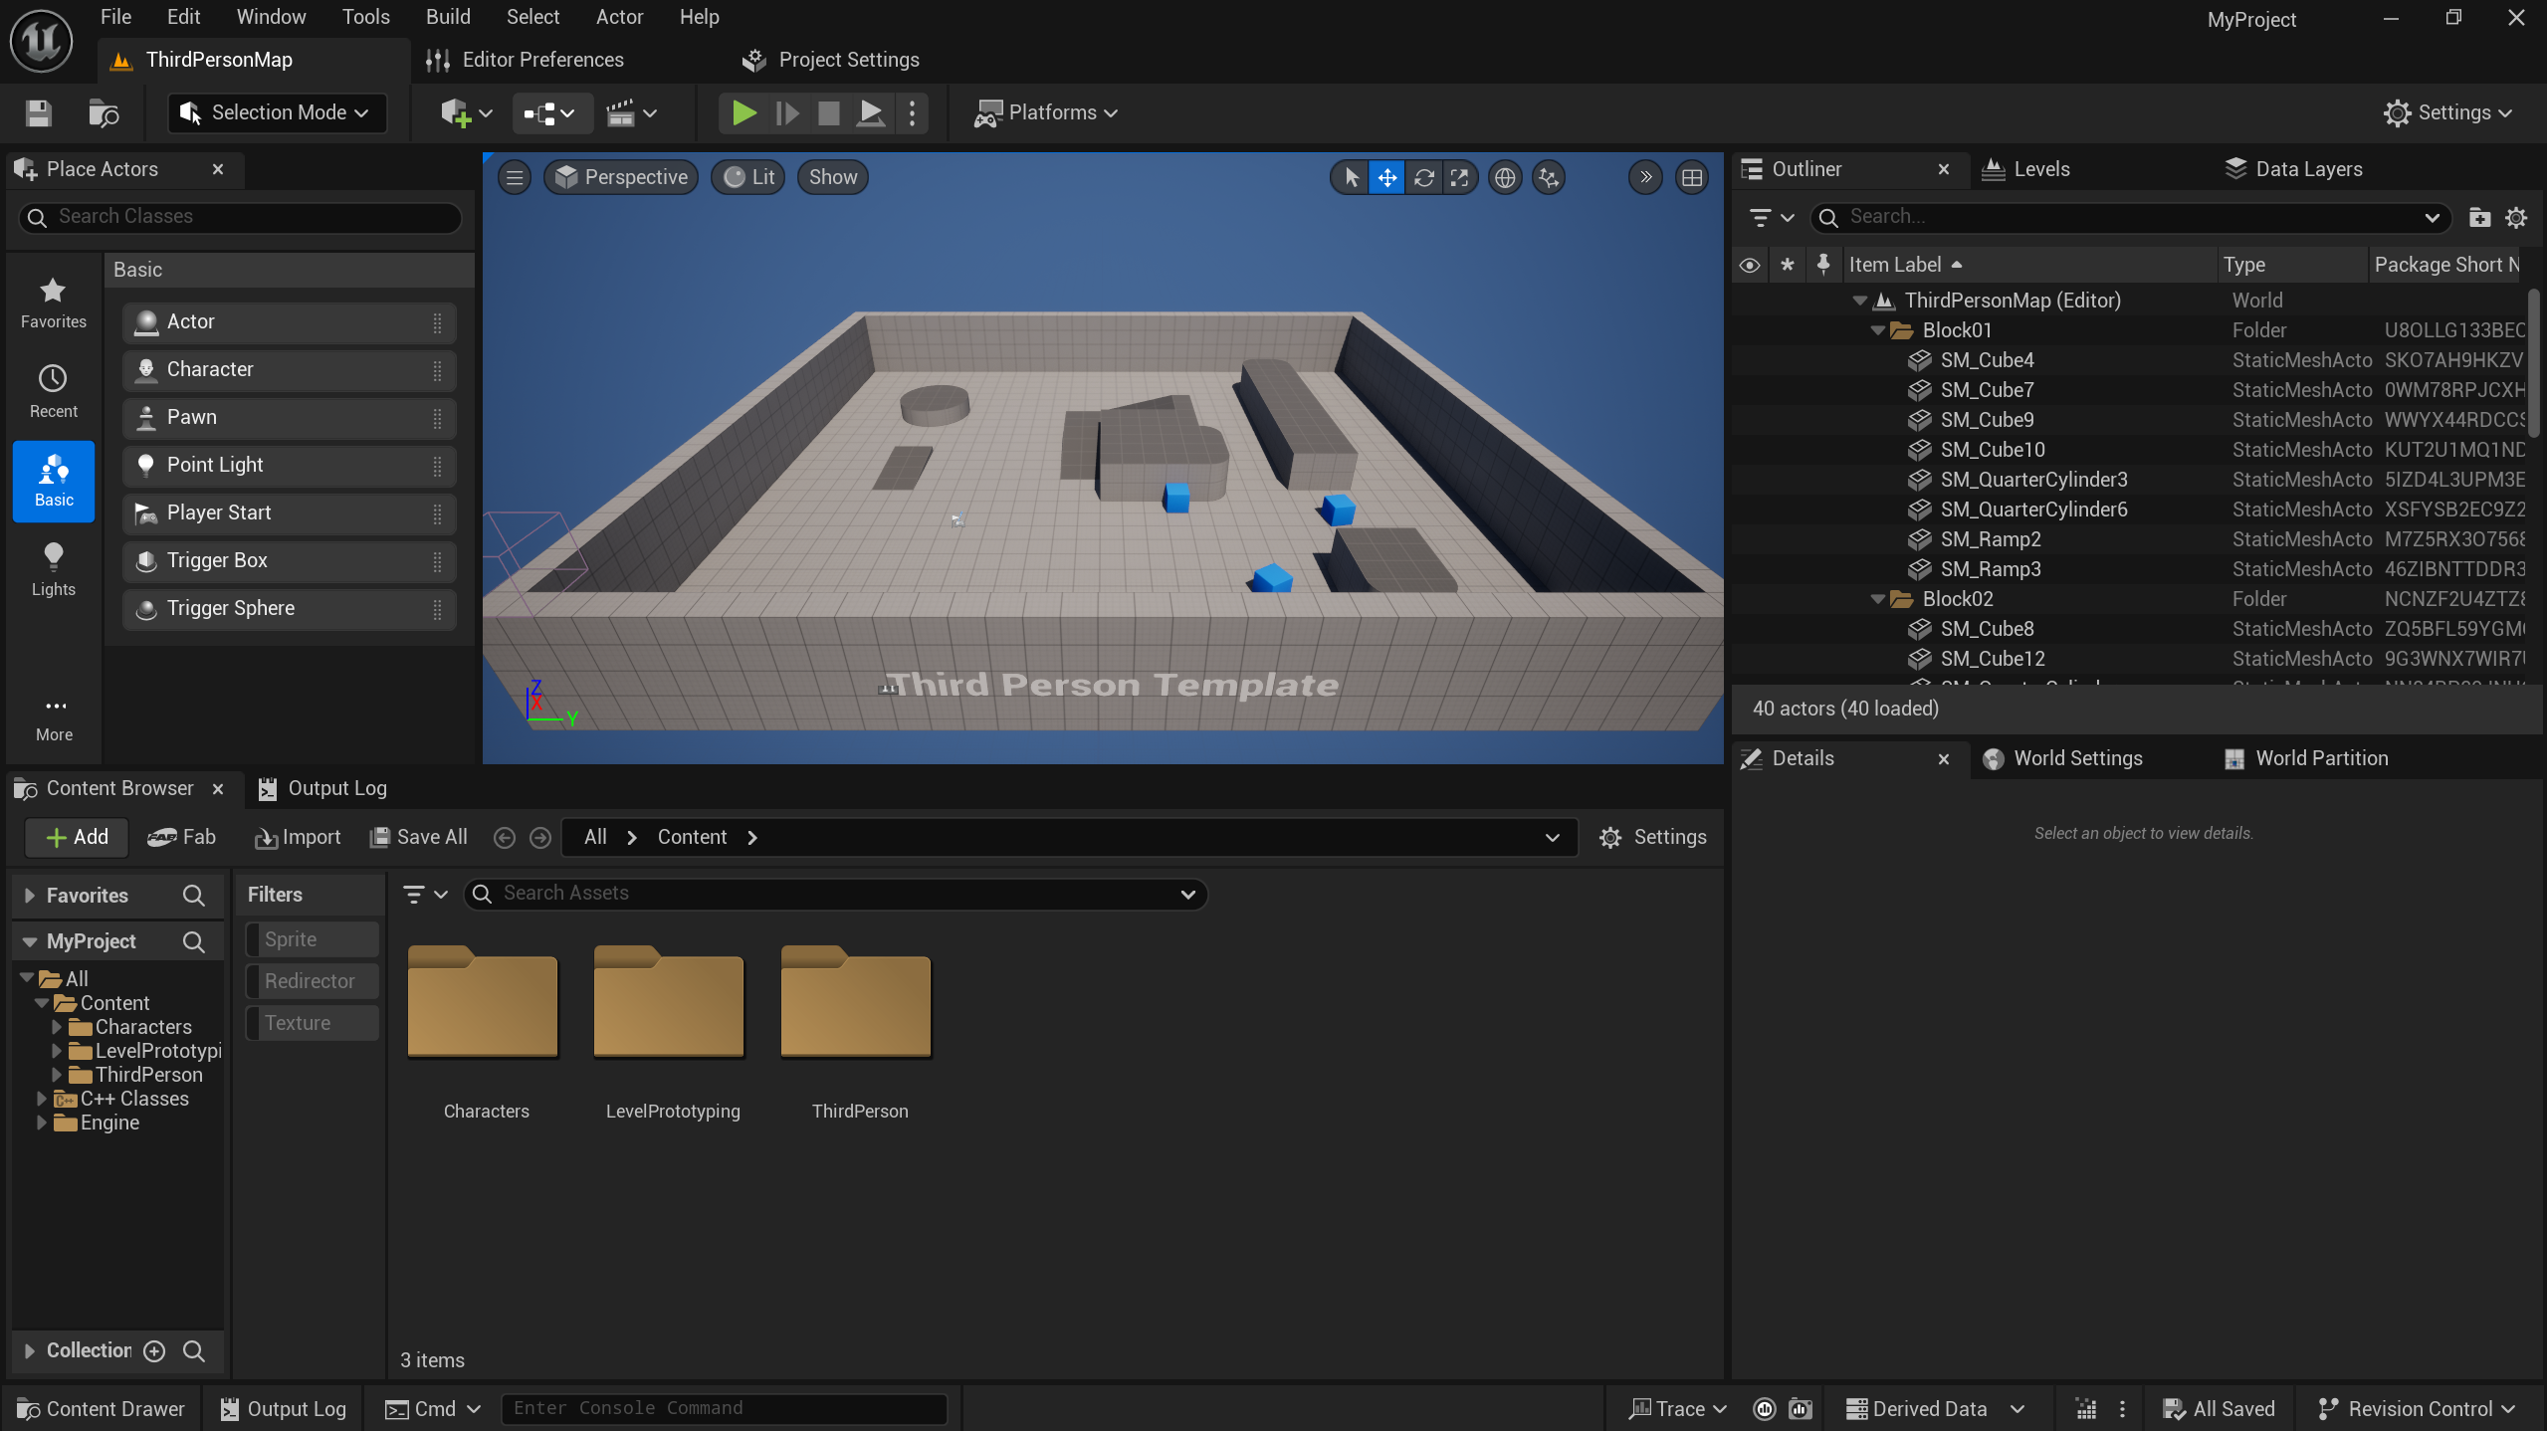
- The project should launch without any issues.
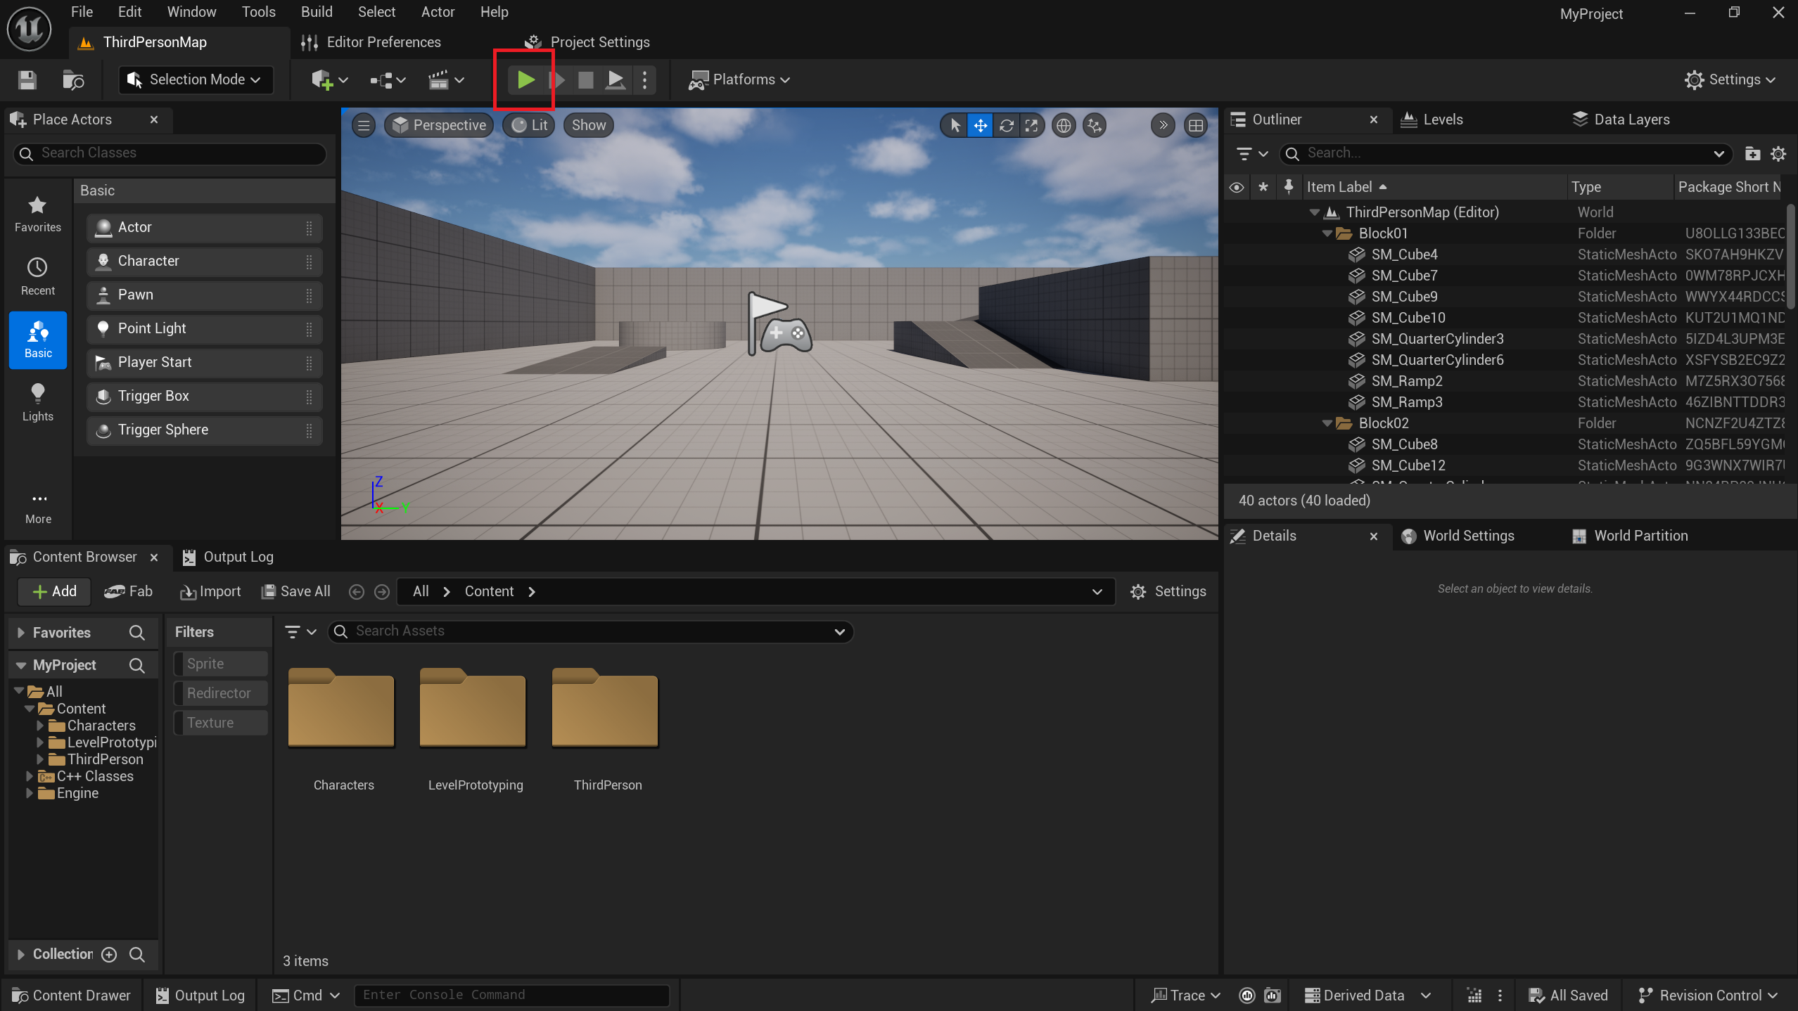
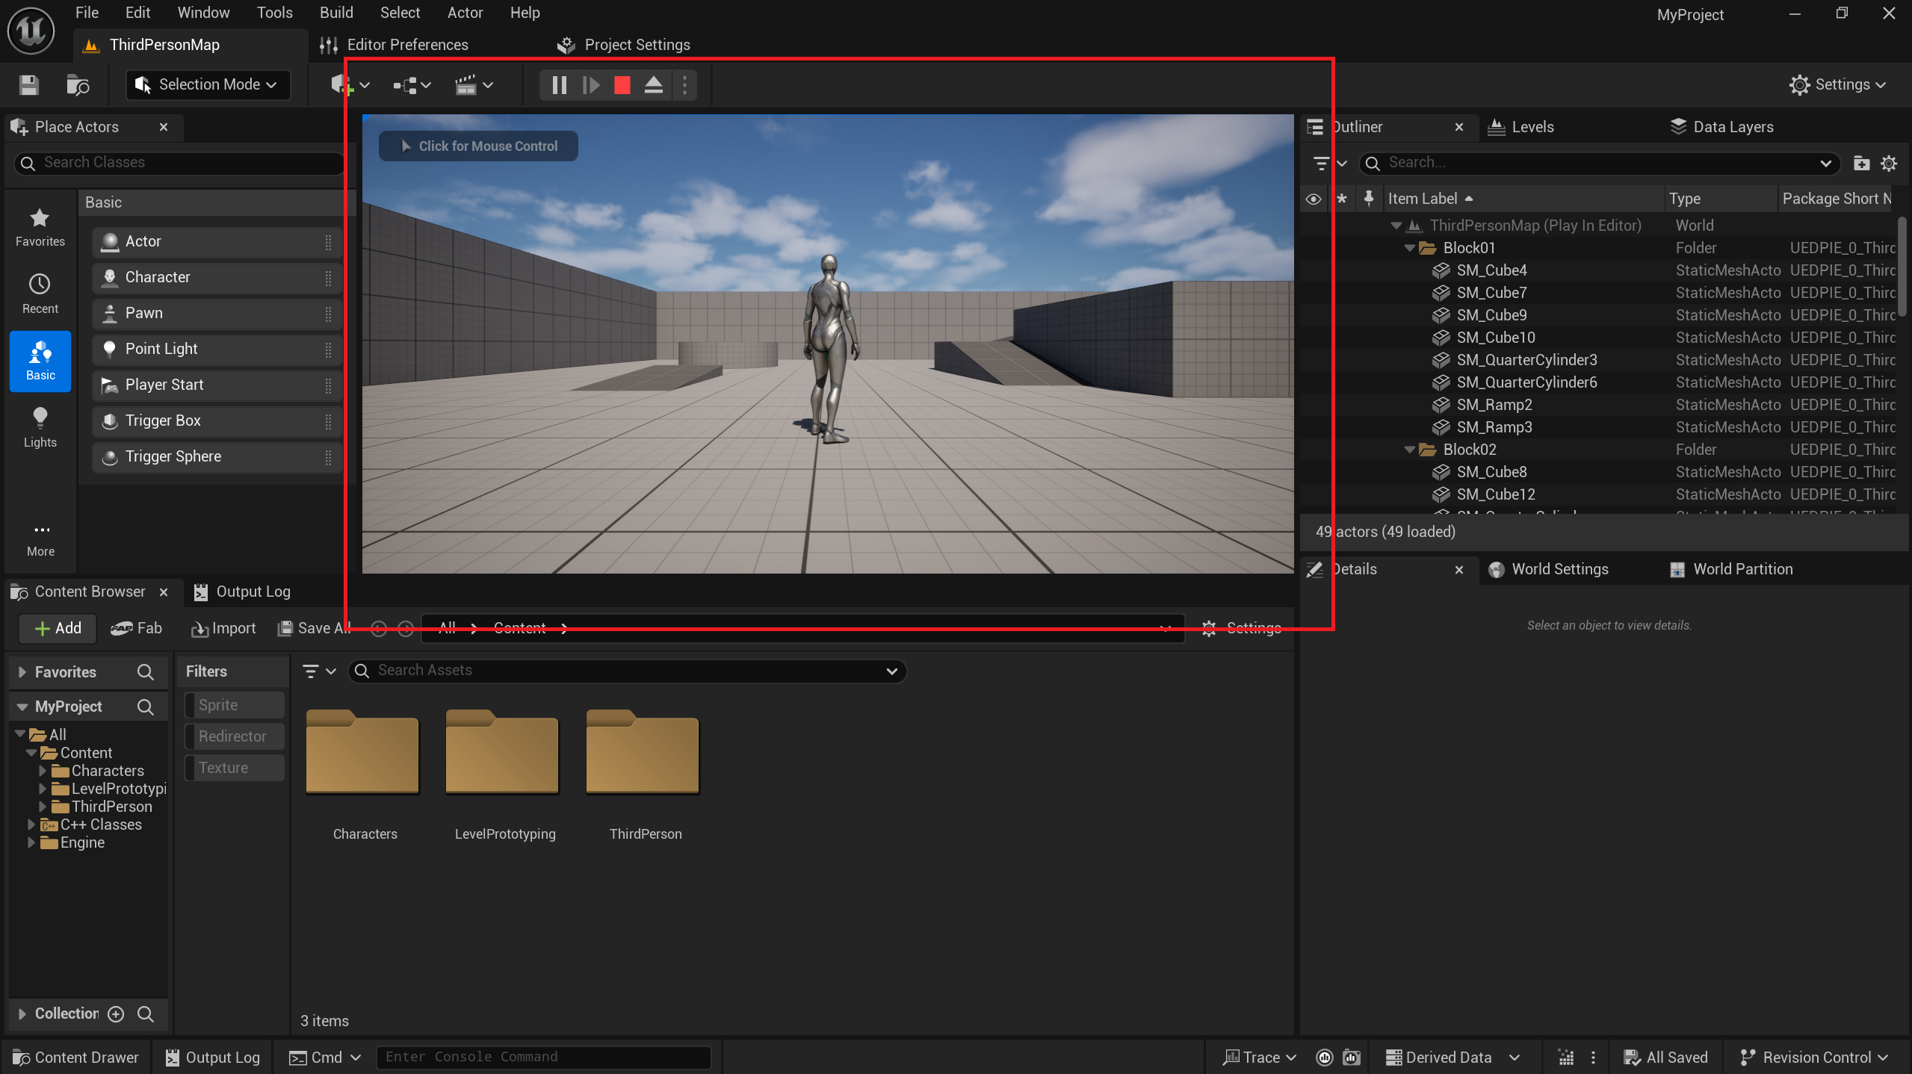
- Our test is not yet complete. Now, we will add an empty C++ class to the project.
Click on New C++ Class….
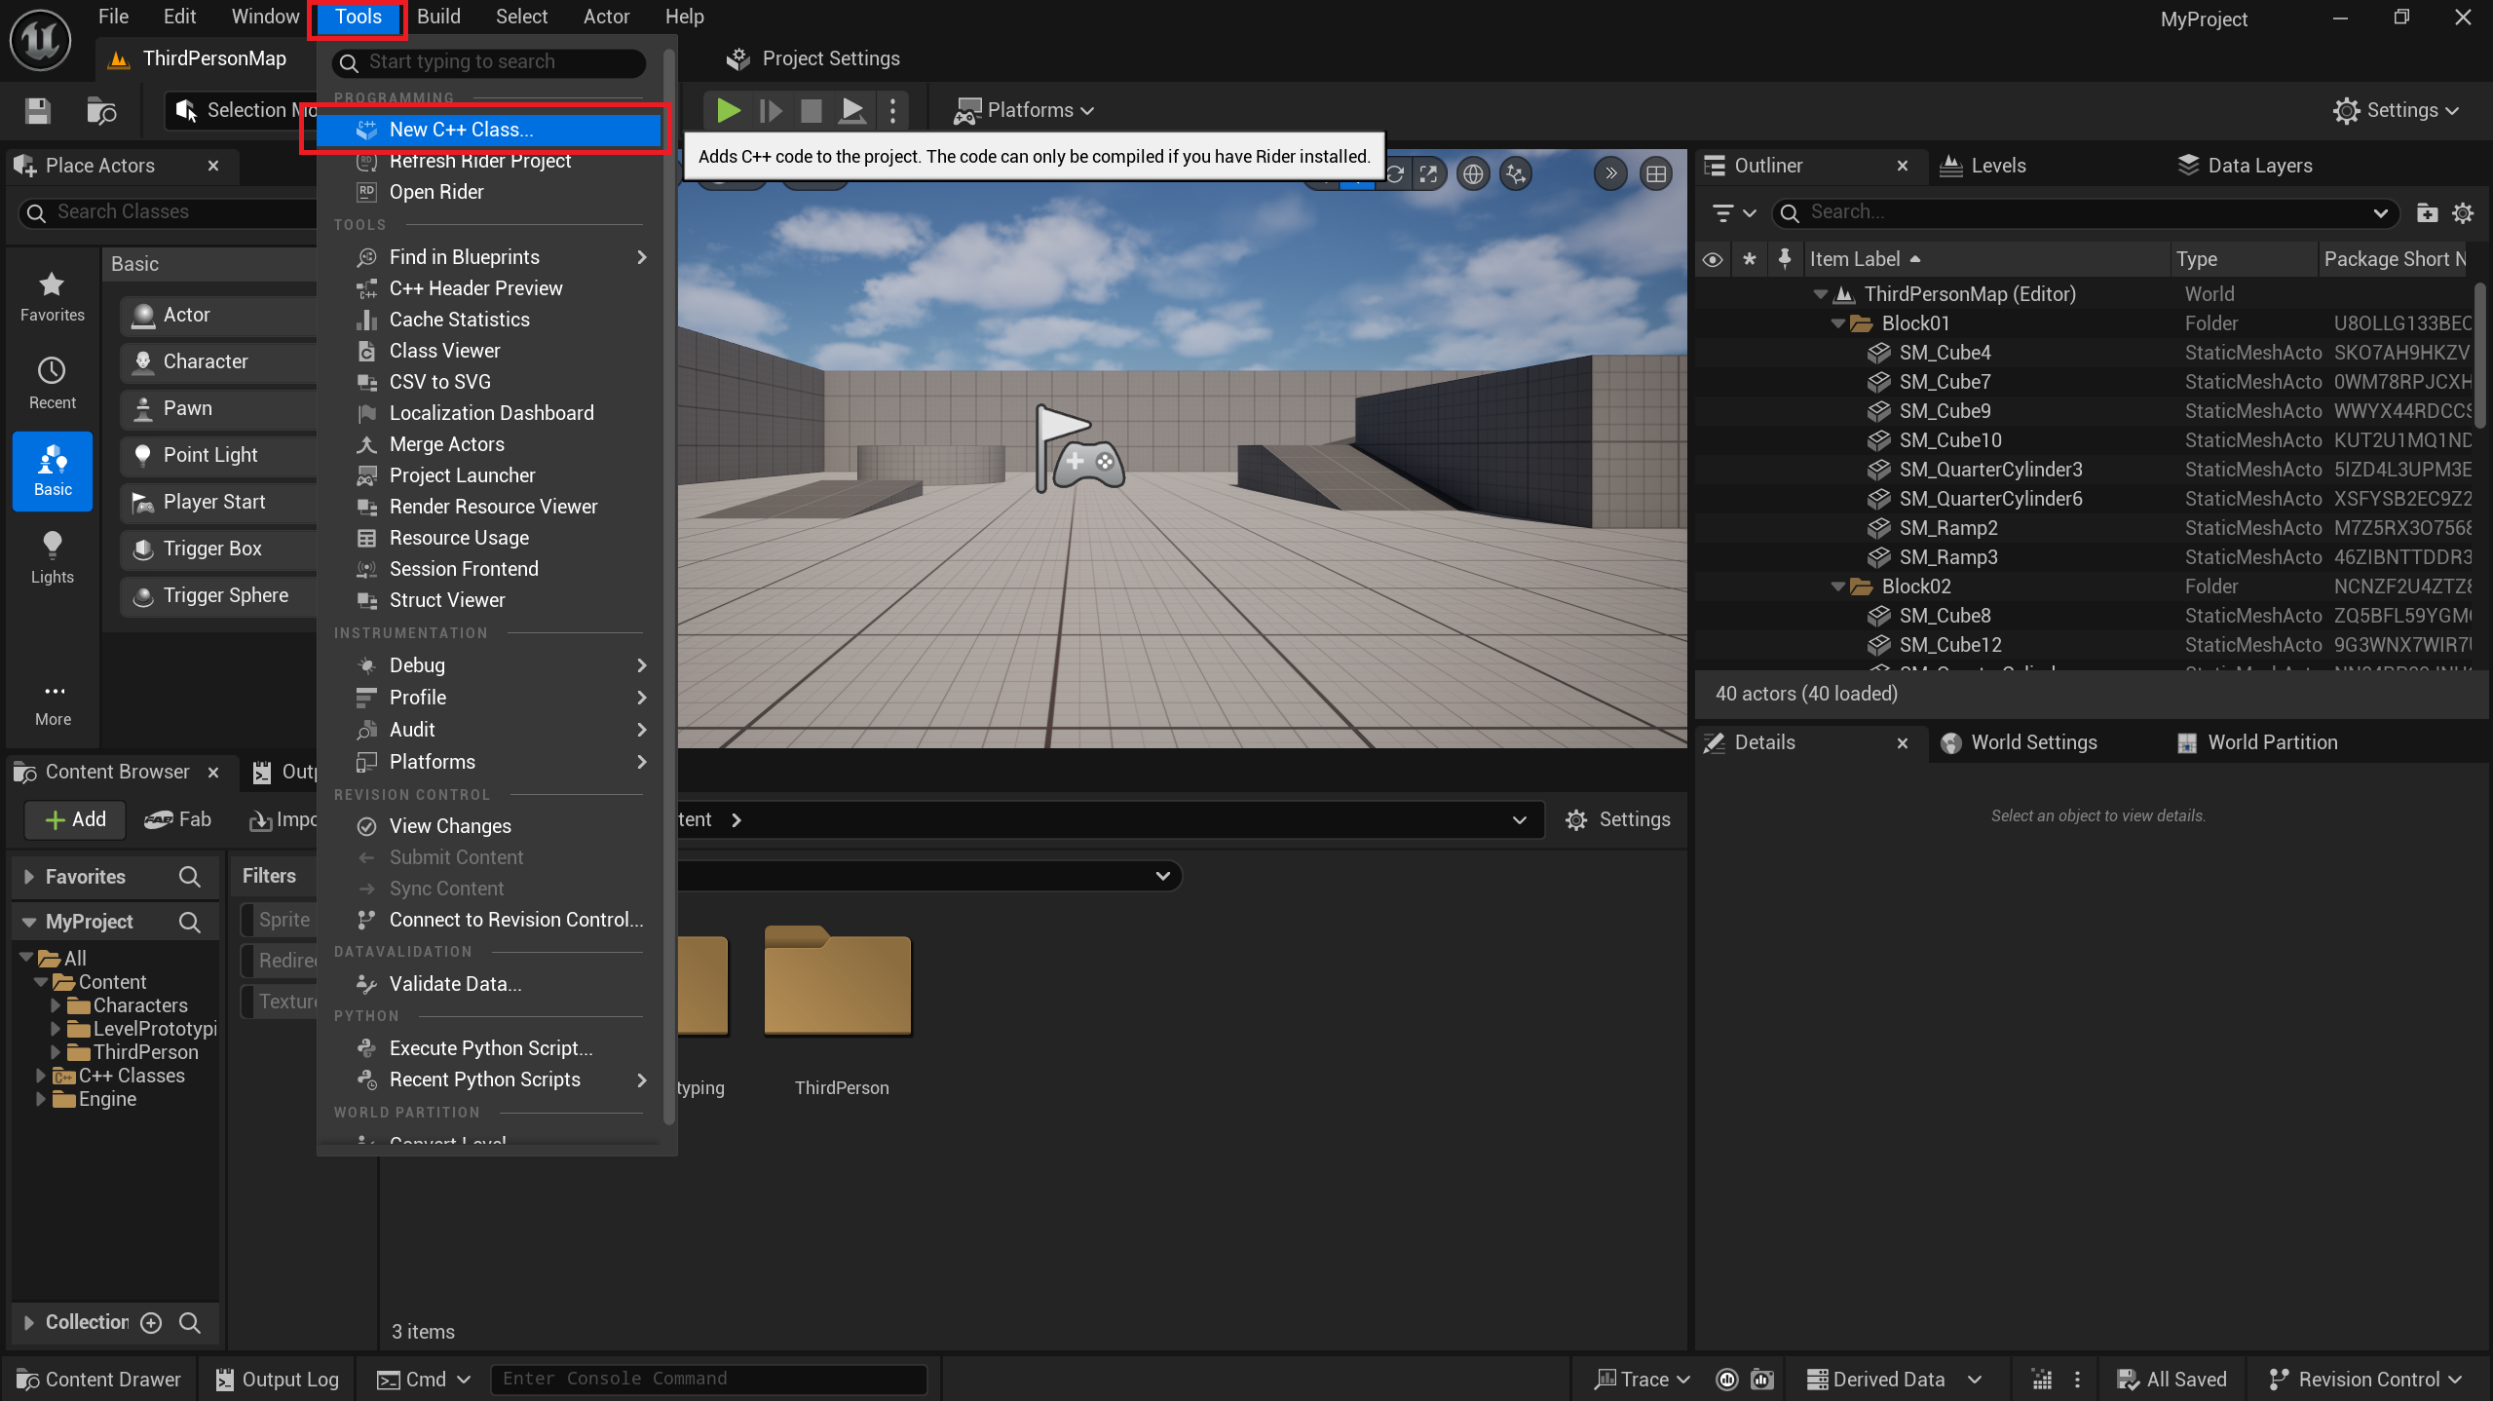
- Select the Actor class and click Next.
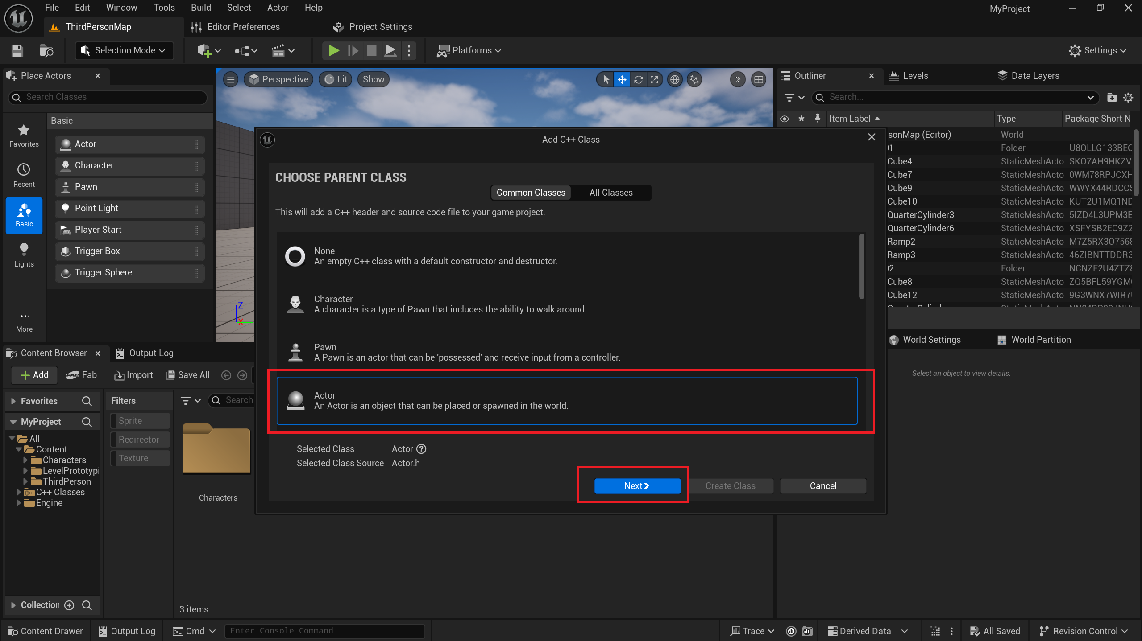
- Leave the class name as default, then click Create Class.
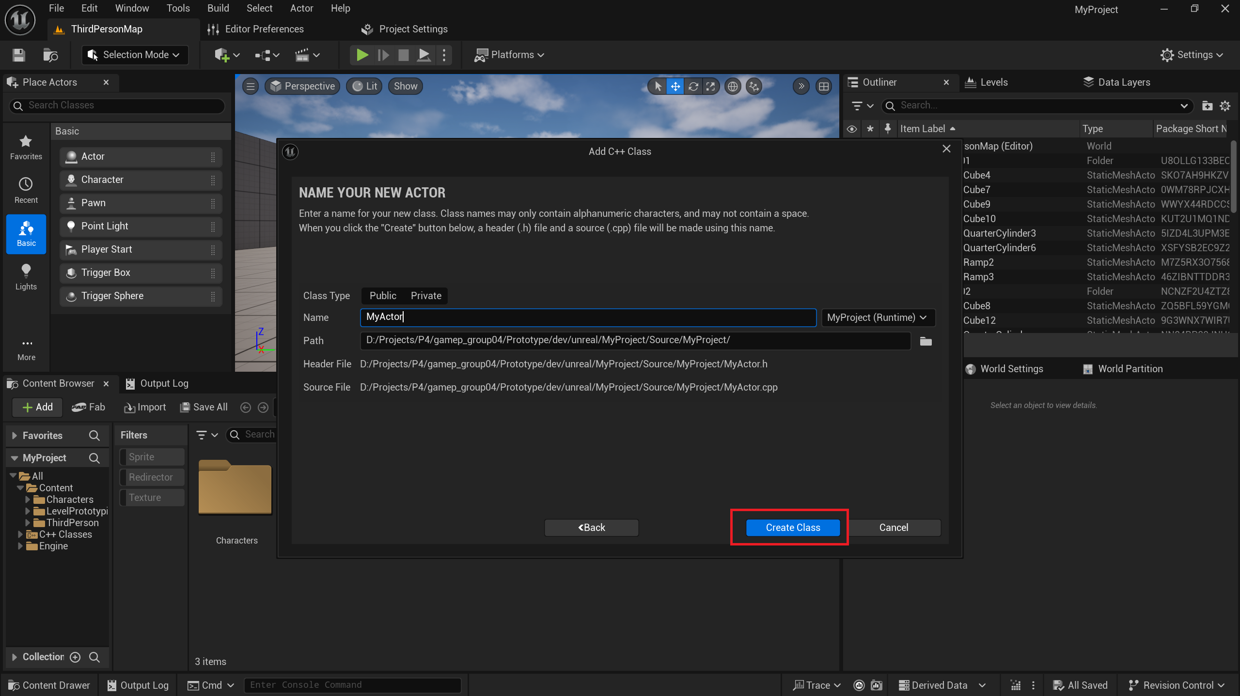
- The Live Coding window will automatically appear, and the class compilation will begin.
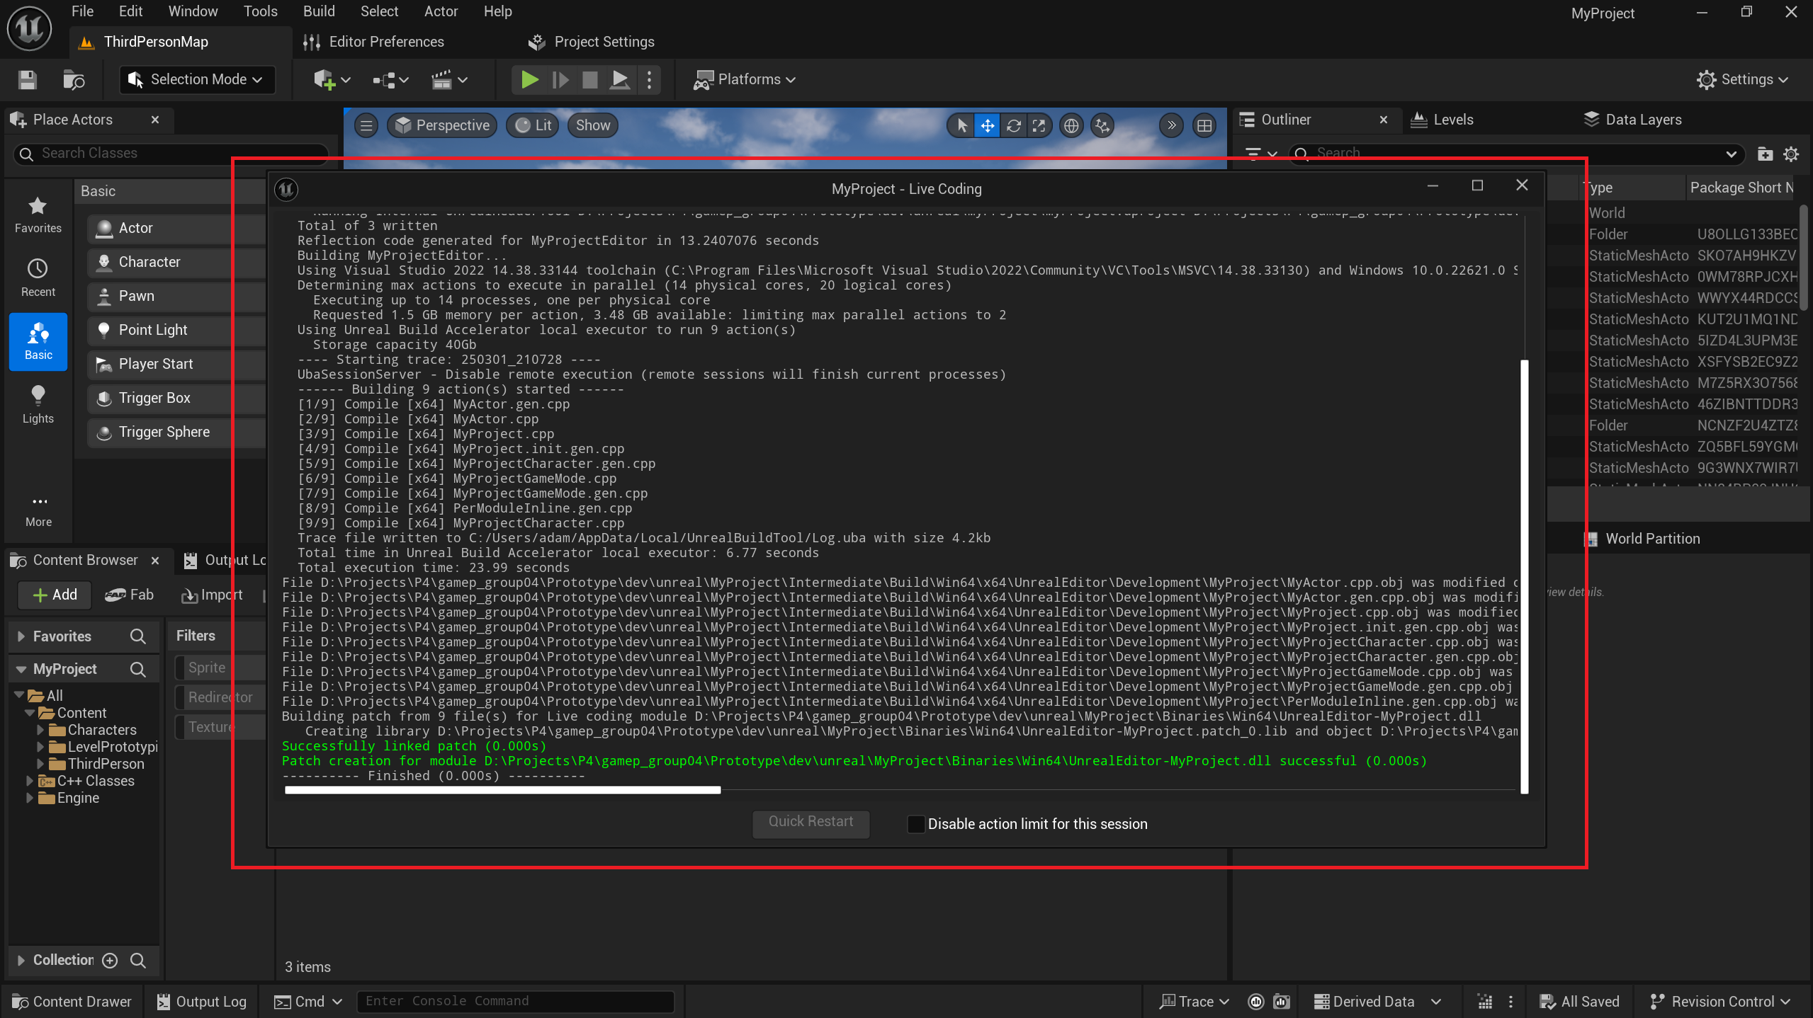
- If the compilation is successful, the final message in the Live Coding window should appear in green, displaying: "Successfully linked patch."
Additionally, a pop-up notification in the bottom-left corner will confirm: "Live coding succeeded."
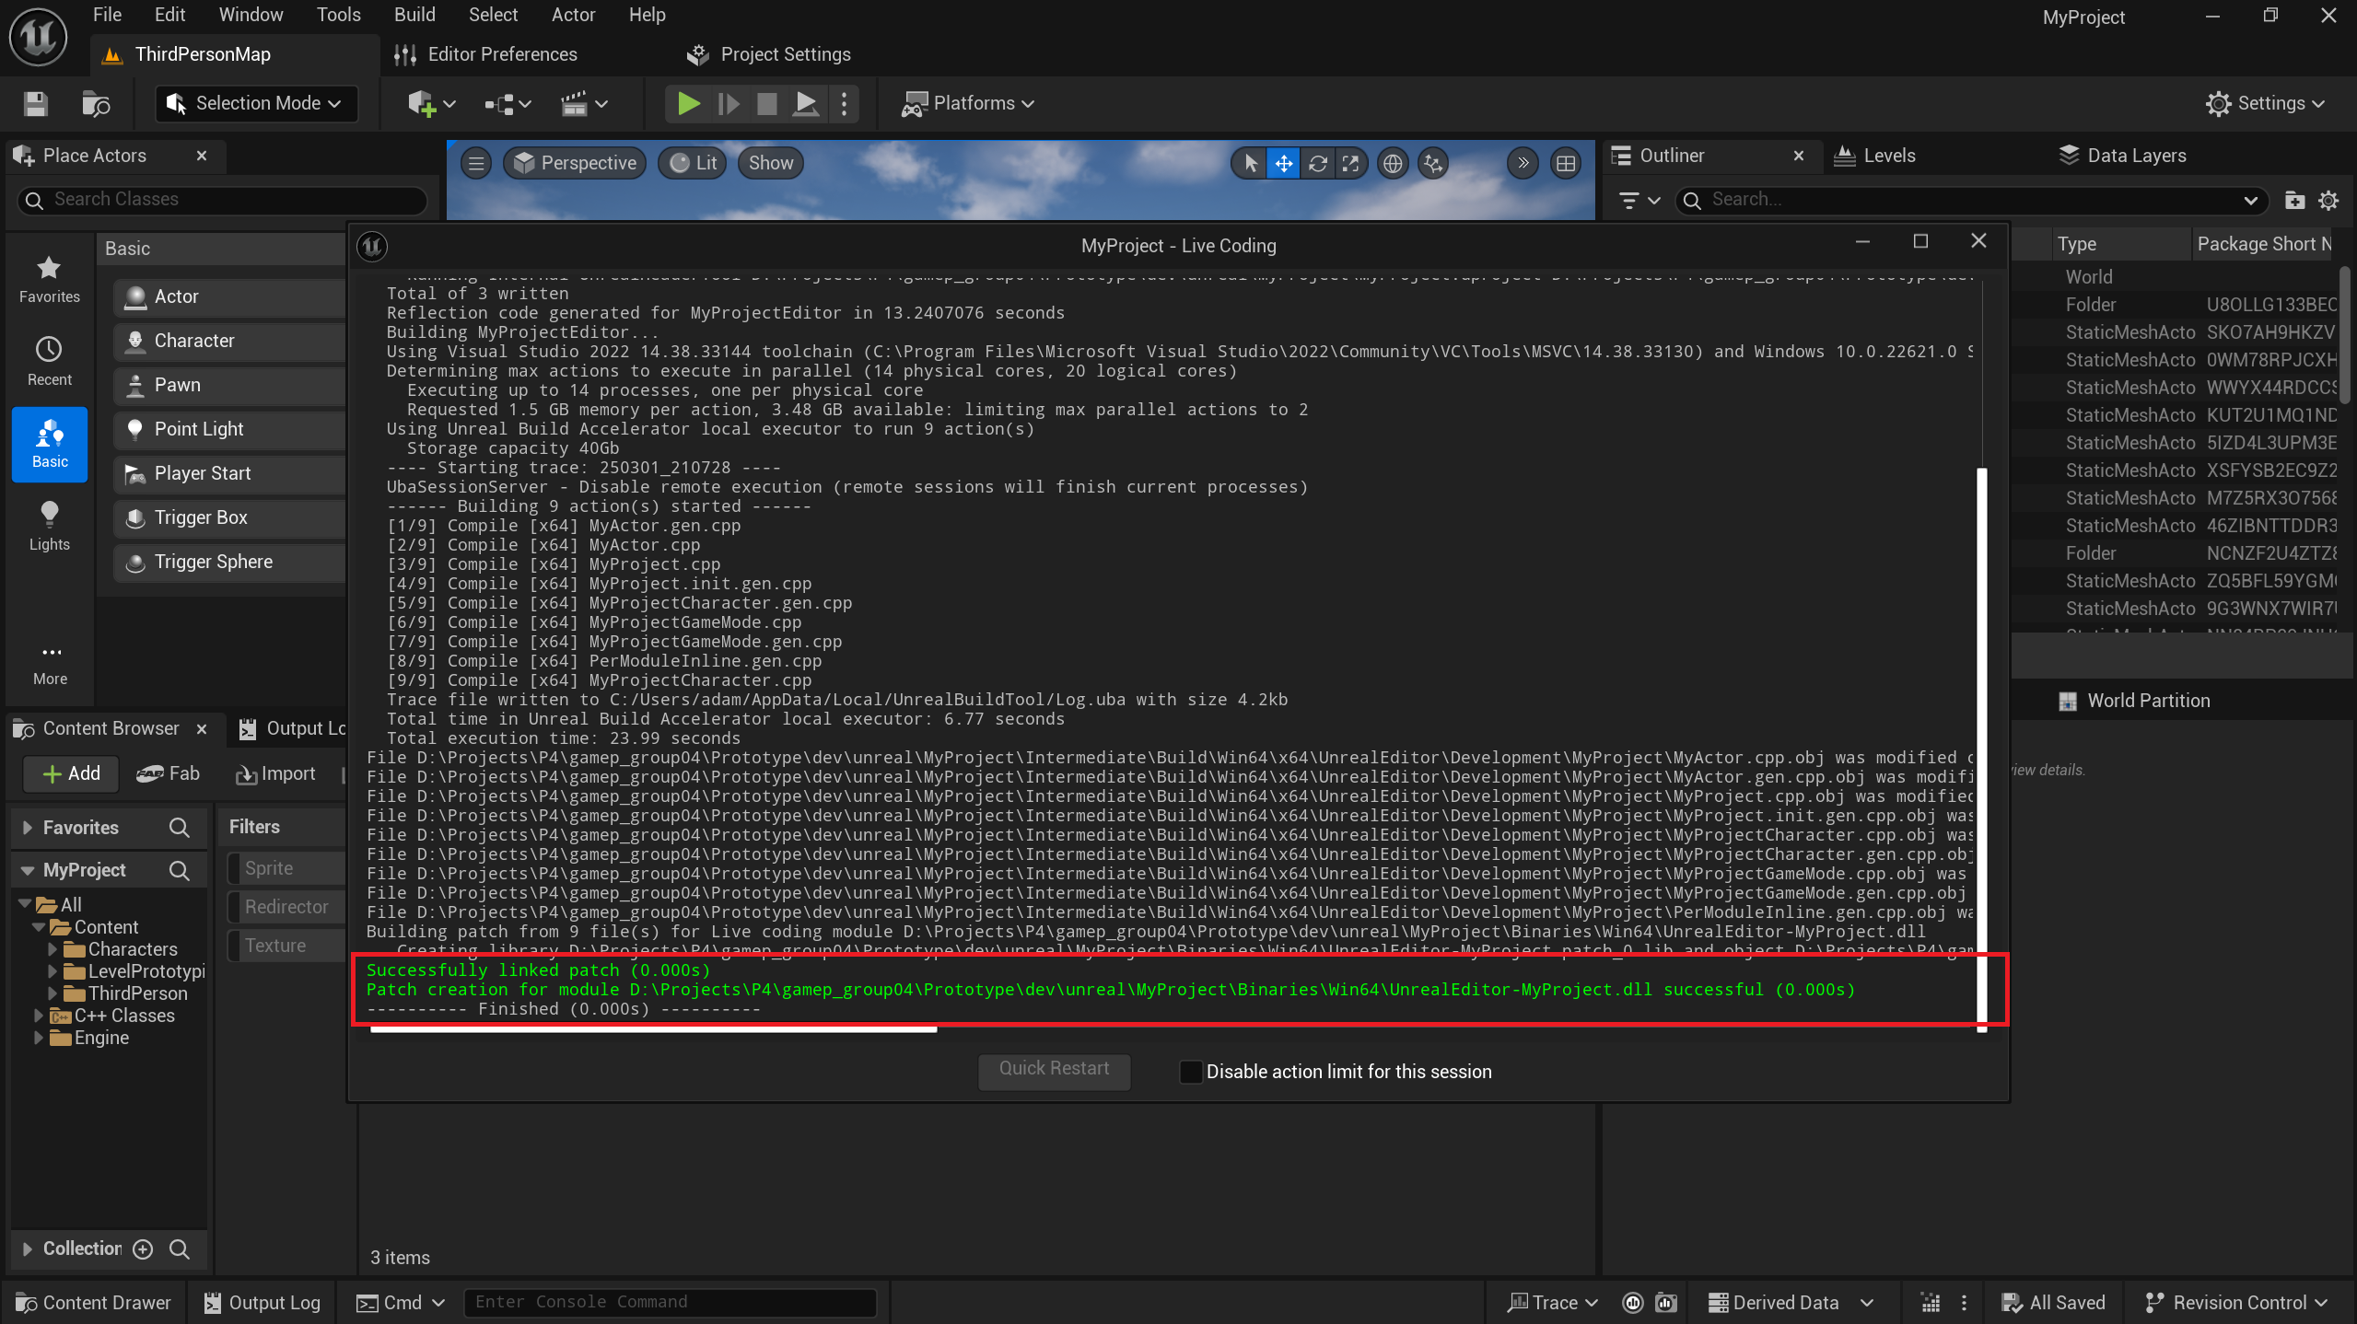
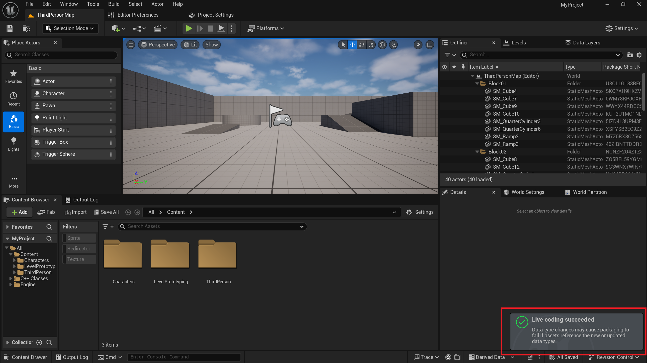
- Double-check that the compiled class is visible in Unreal Engine.
In the bottom-left corner, click on the project name (in this case, our test project was created as MyProject).
The newly created class should be visible within the folder.
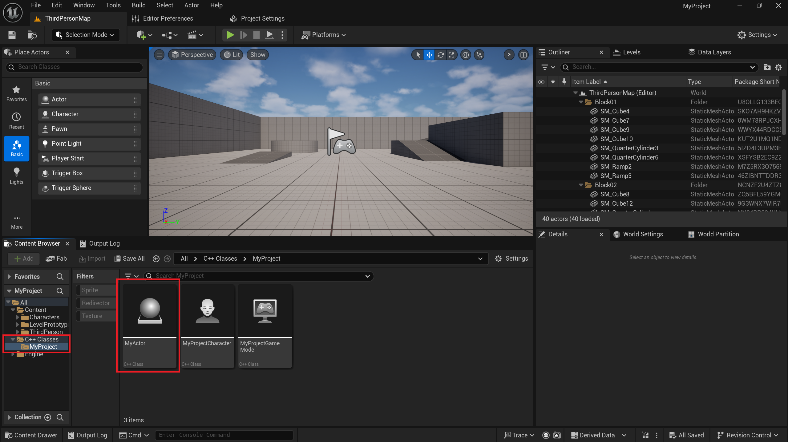

Opening a C++ Project
In some cases, we need to open an existing C++ Unreal project.
Ideally, the project should include three folders (Config, Content, Source) and a .uproject file.
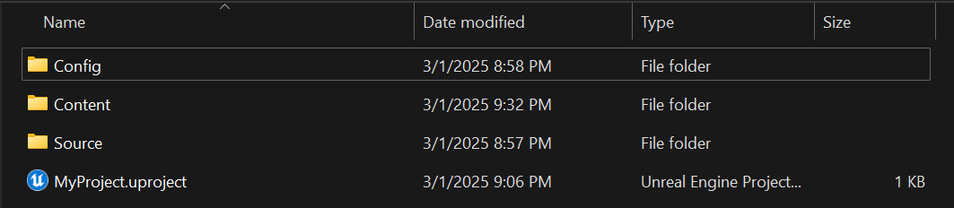
The following steps will demonstrate the process of successfully generating the project.
- Right-click on the .uproject file, then select Show more options.
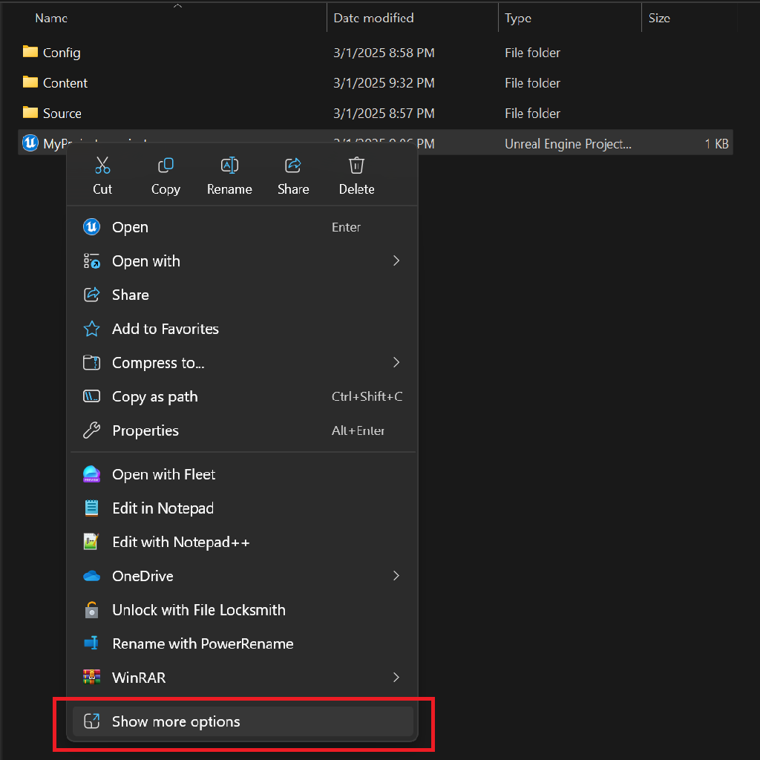
- Click on Generate Visual Studio project files.
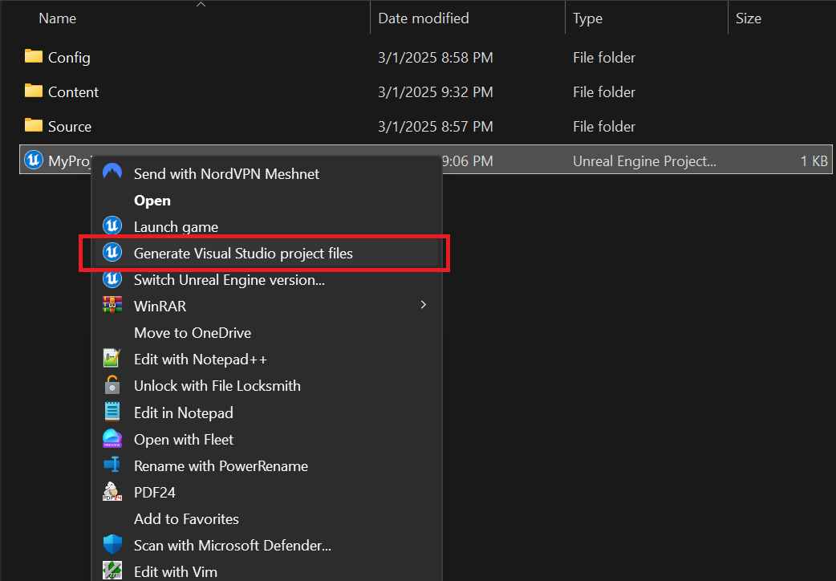
- Project file generation in progress...
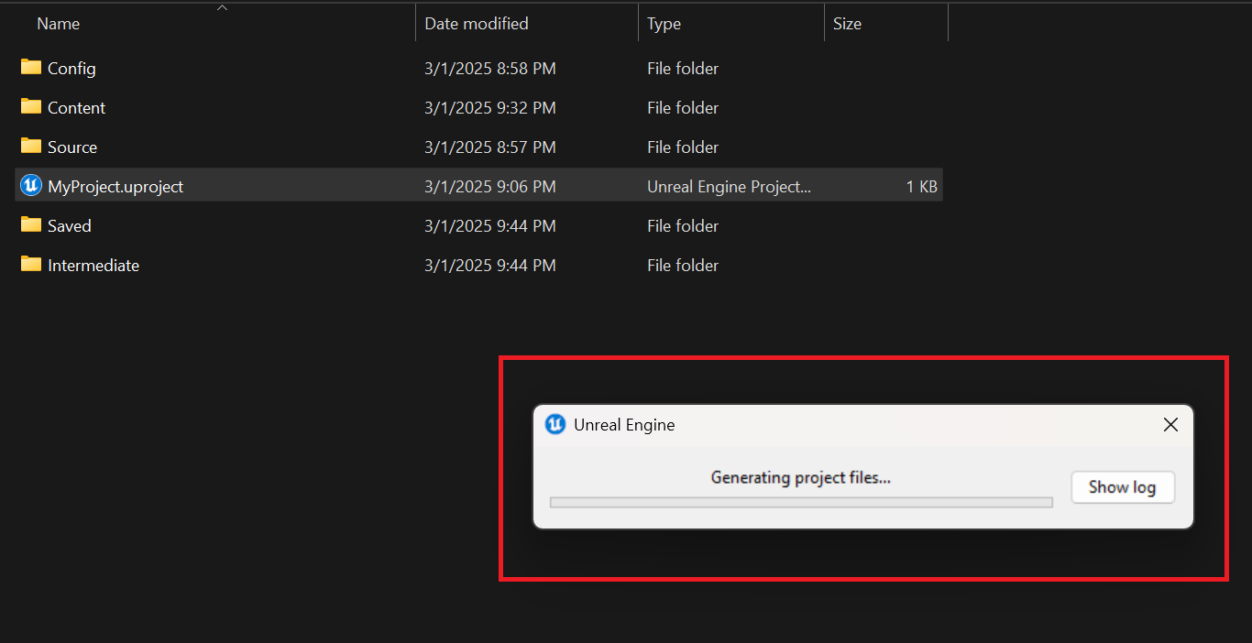
- In addition to the existing folders, new directories have been created.
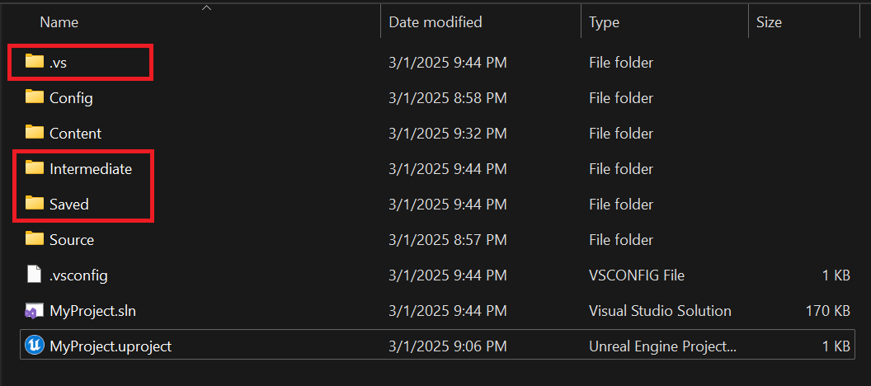
- Most importantly, a .sln file has also been generated.
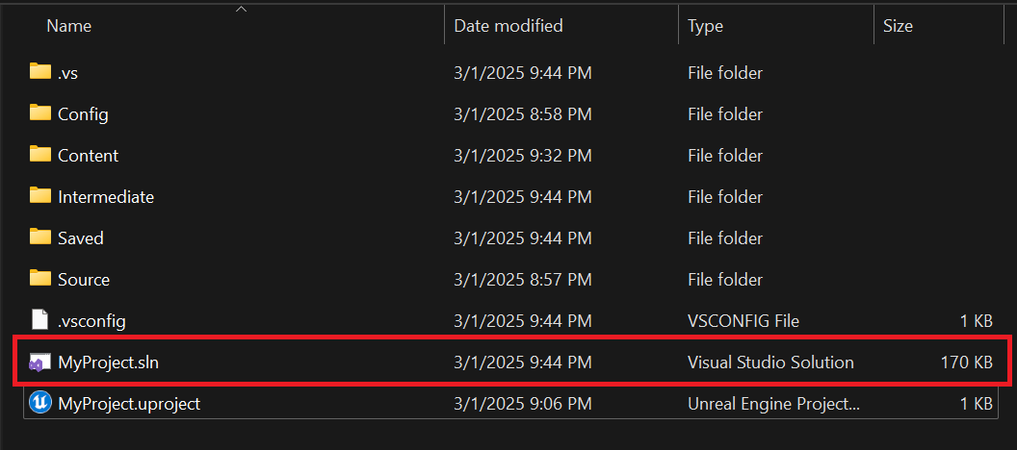
- Next, double-click the .uproject file. A prompt will appear - click Yes to proceed.
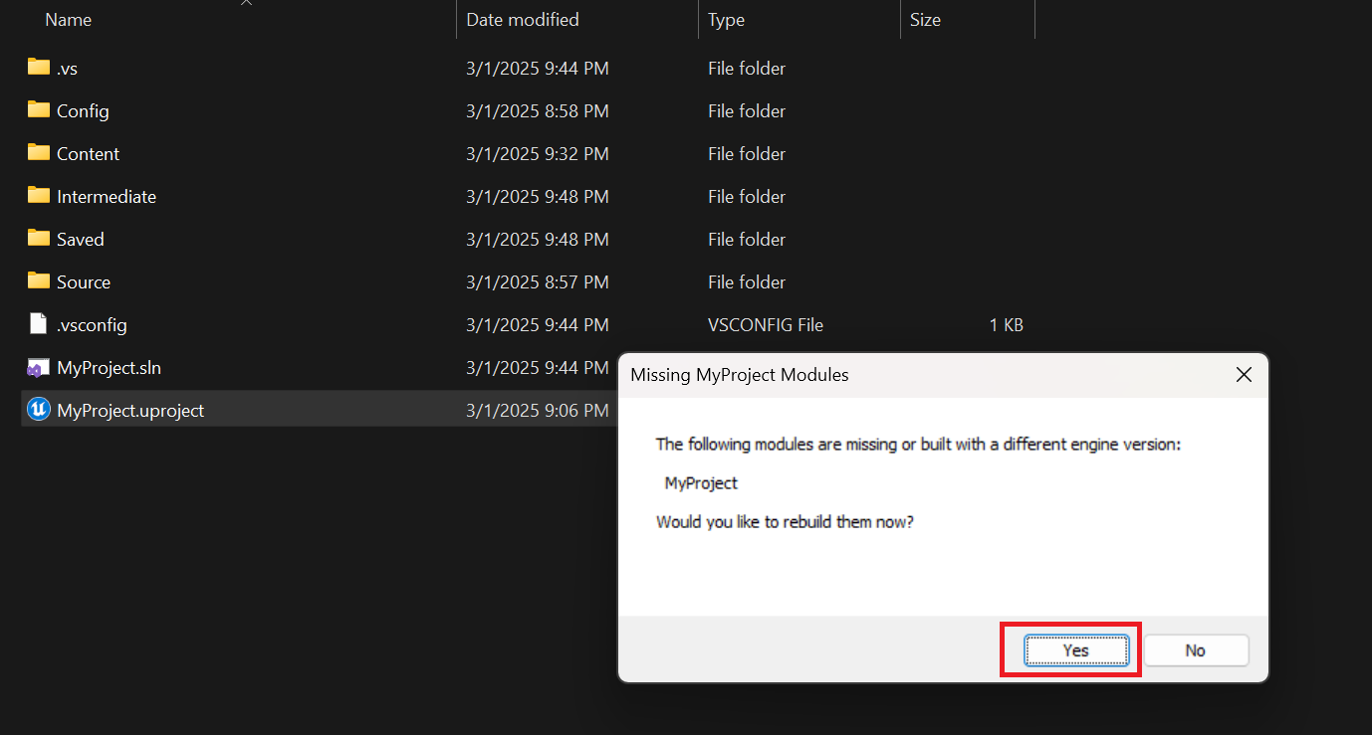
- Unreal Engine will begin building the project.
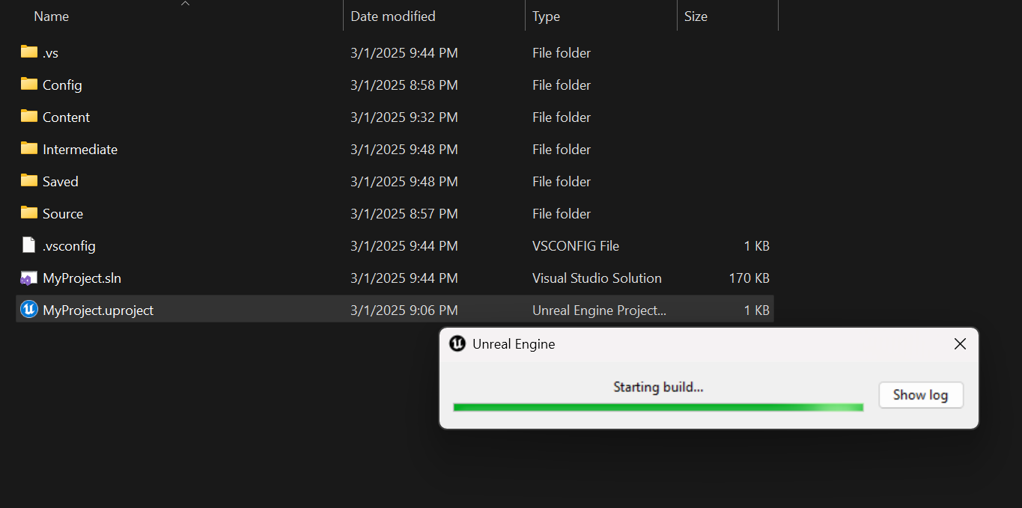
- If the build is successful, the project will open.
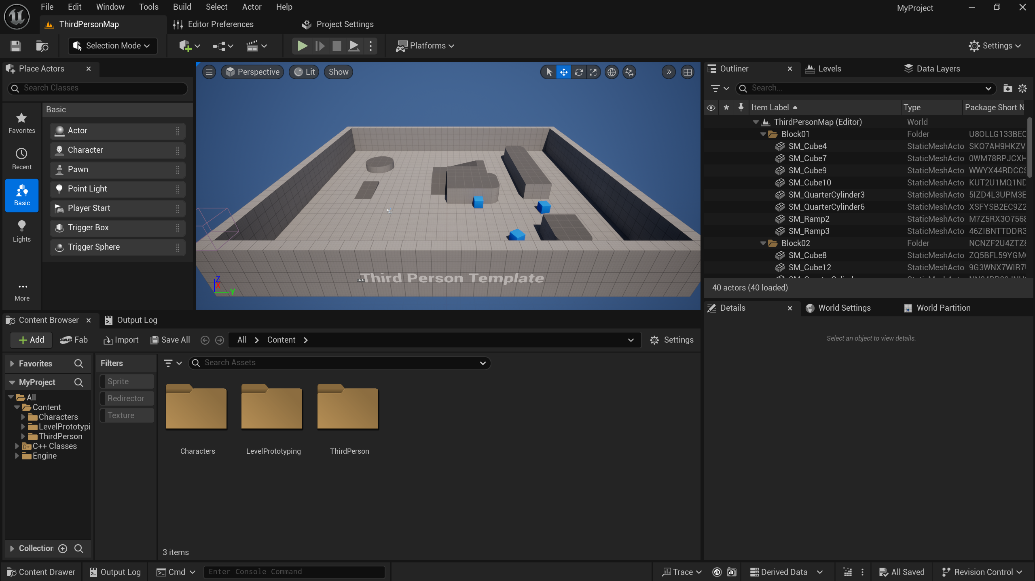

Plugins
At this moment, apart from the default-enabled plugins, we are not using any additional plugins.
Certain custom plugins may cause compilation errors, preventing the project from launching. These must be disabled unless they are essential for the project.
One such example is the Houdini plugin. If we encounter an error message during project creation, this plugin is likely the cause:
Expecting to find a type to be declared in a module rules named 'HoudiniEngine' in 'UE5Rules, Version=0.0.0.0, Culture=neutral, PublicKeyToken=null'. This type must derive from the 'ModuleRules' type defined by UnrealBuildTool.
The following process demonstrates how to disable it.
- Locate the HoudiniEngine.uplugin file. By default, its path is:
C:\Program Files\Epic Games\UE_5.5\Engine\Plugins\Runtime\HoudiniEngine
- If we cannot find it, use the Everything search application. (We will discuss the Everything application in the Other Tools section.)
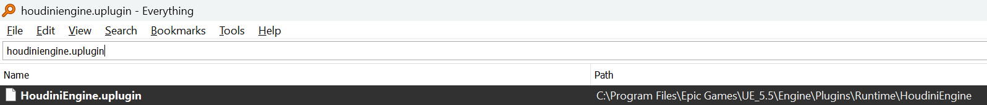
- Open the file in a text editor of your choice and change the EnabledByDefault value from true to false.
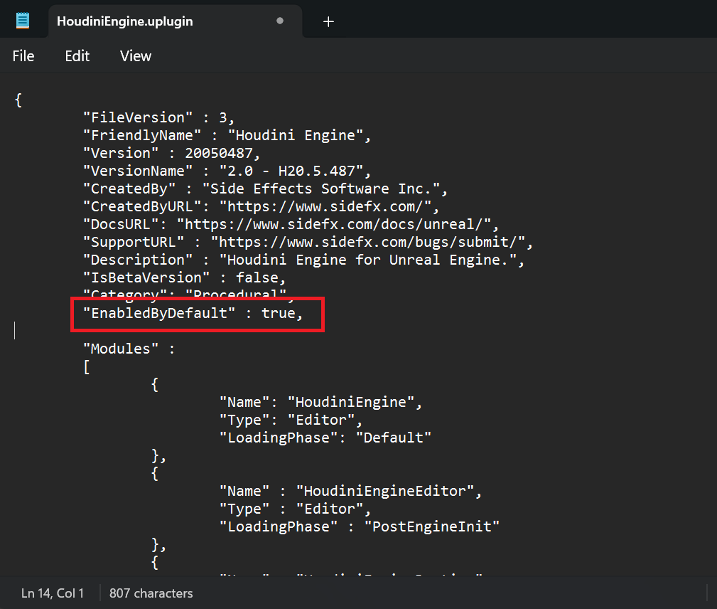
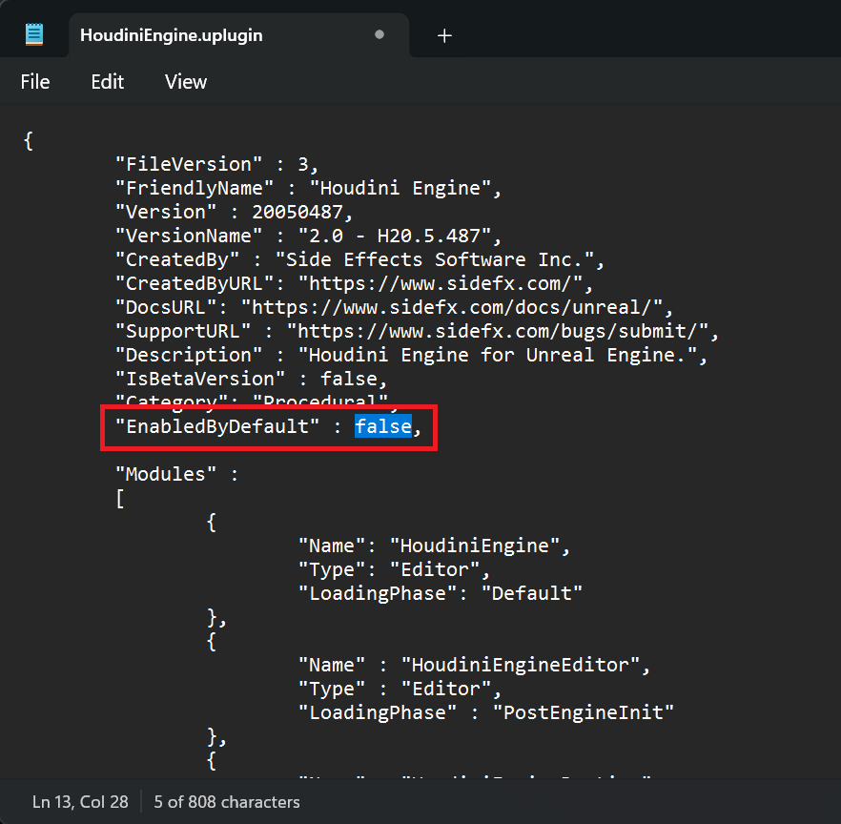
- Save the file and reopen the desired Unreal Engine project. The project should now open without issues.

IDE

Visual Studio
The development tools will be installed via the Visual Studio Installer application.
In addition to various C/C++/C# components, we will require a default Integrated Development Environment (IDE). As the industry-standard IDE for game development, Visual Studio will be our starting point. We will use the free Community Edition, which includes all the essential tools needed for development.

Links
Visual Studio Installer: https://visualstudio.microsoft.com/downloads/
Setting Up Visual Studio: https://dev.epicgames.com/documentation/en-us/unreal-engine/setting-up-visual-studio-development-environment-for-cplusplus-projects-in-unreal-engine

Installation
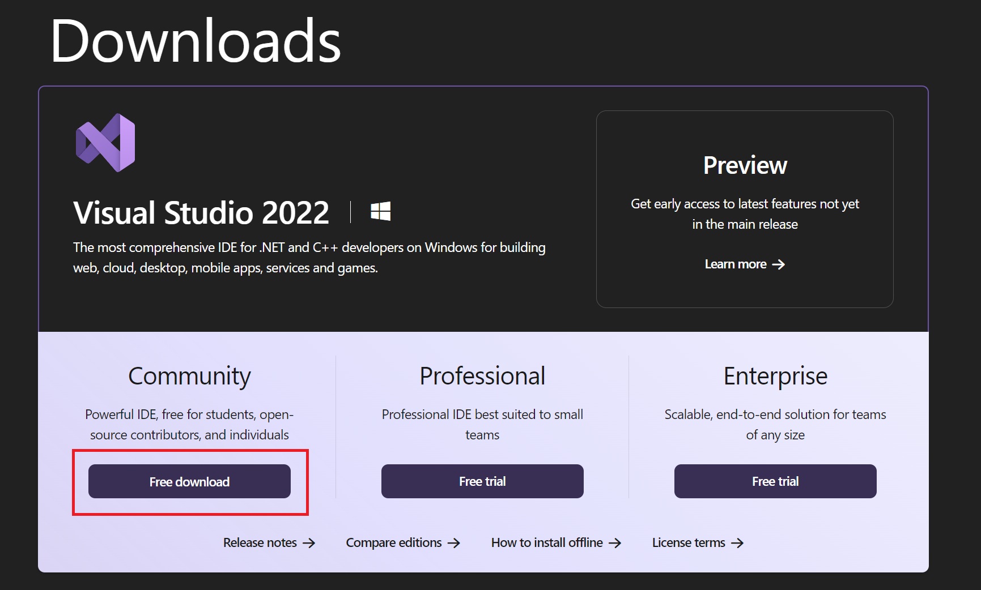
Instead of the 17.10 version recommended by Epic Games, we will use the latest available version at the time of writing this document (17.13.2).
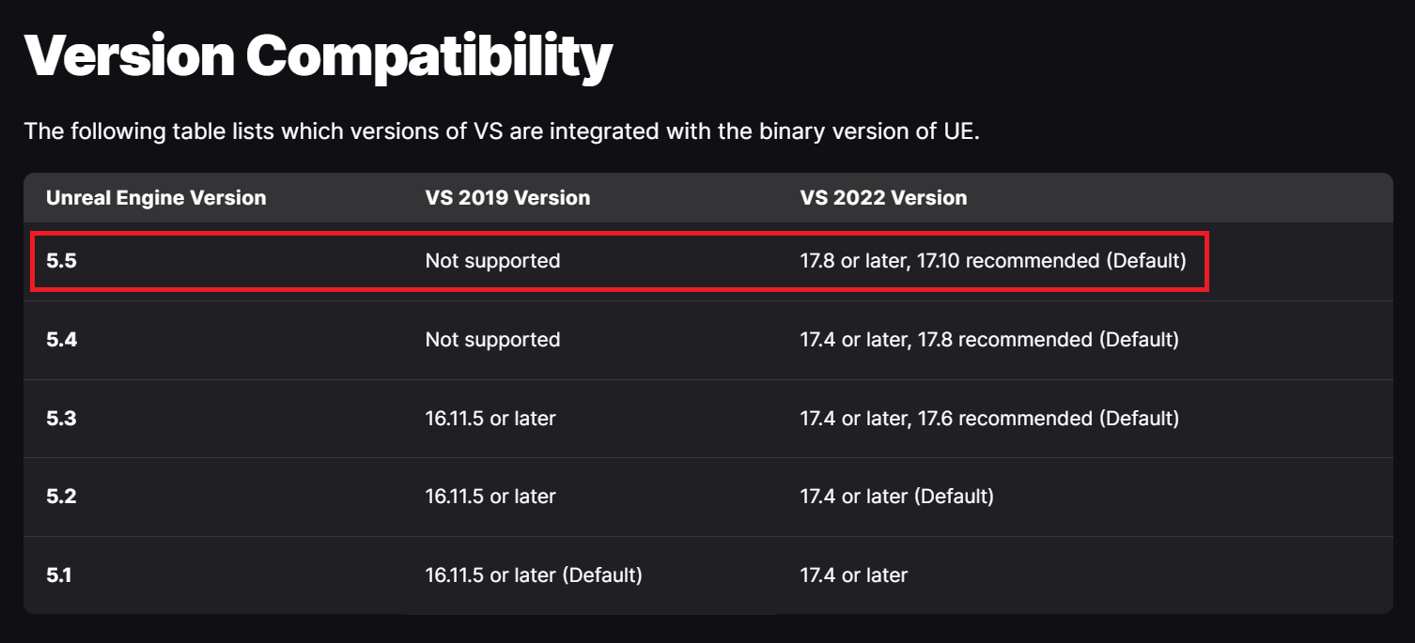
Latest version:
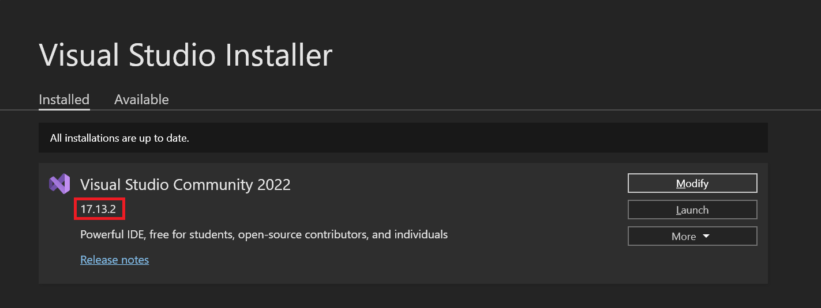

Workloads
For the smooth operation of Unreal Engine, the following modules must be installed:
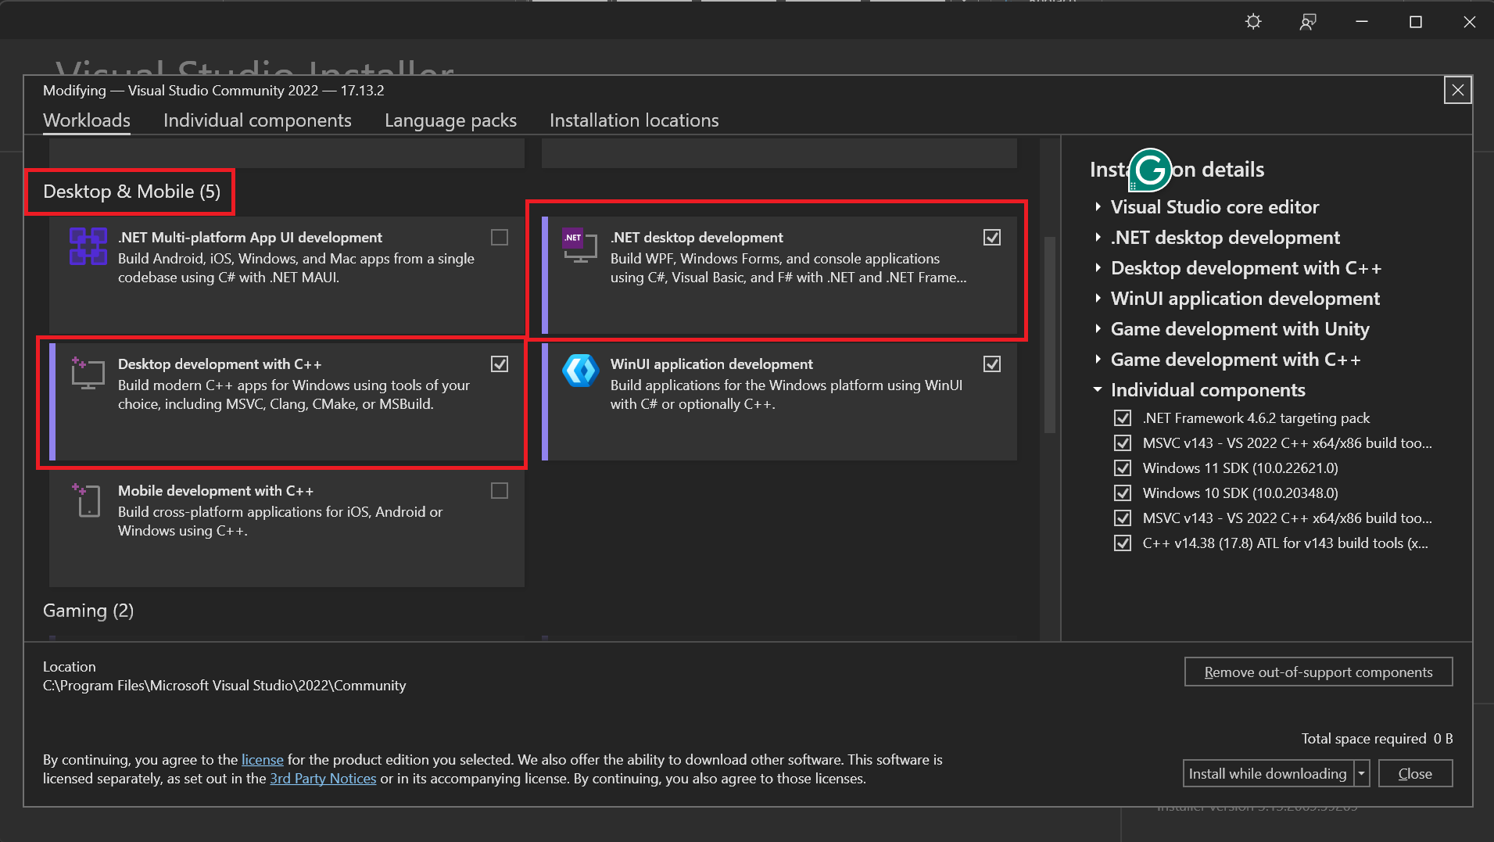
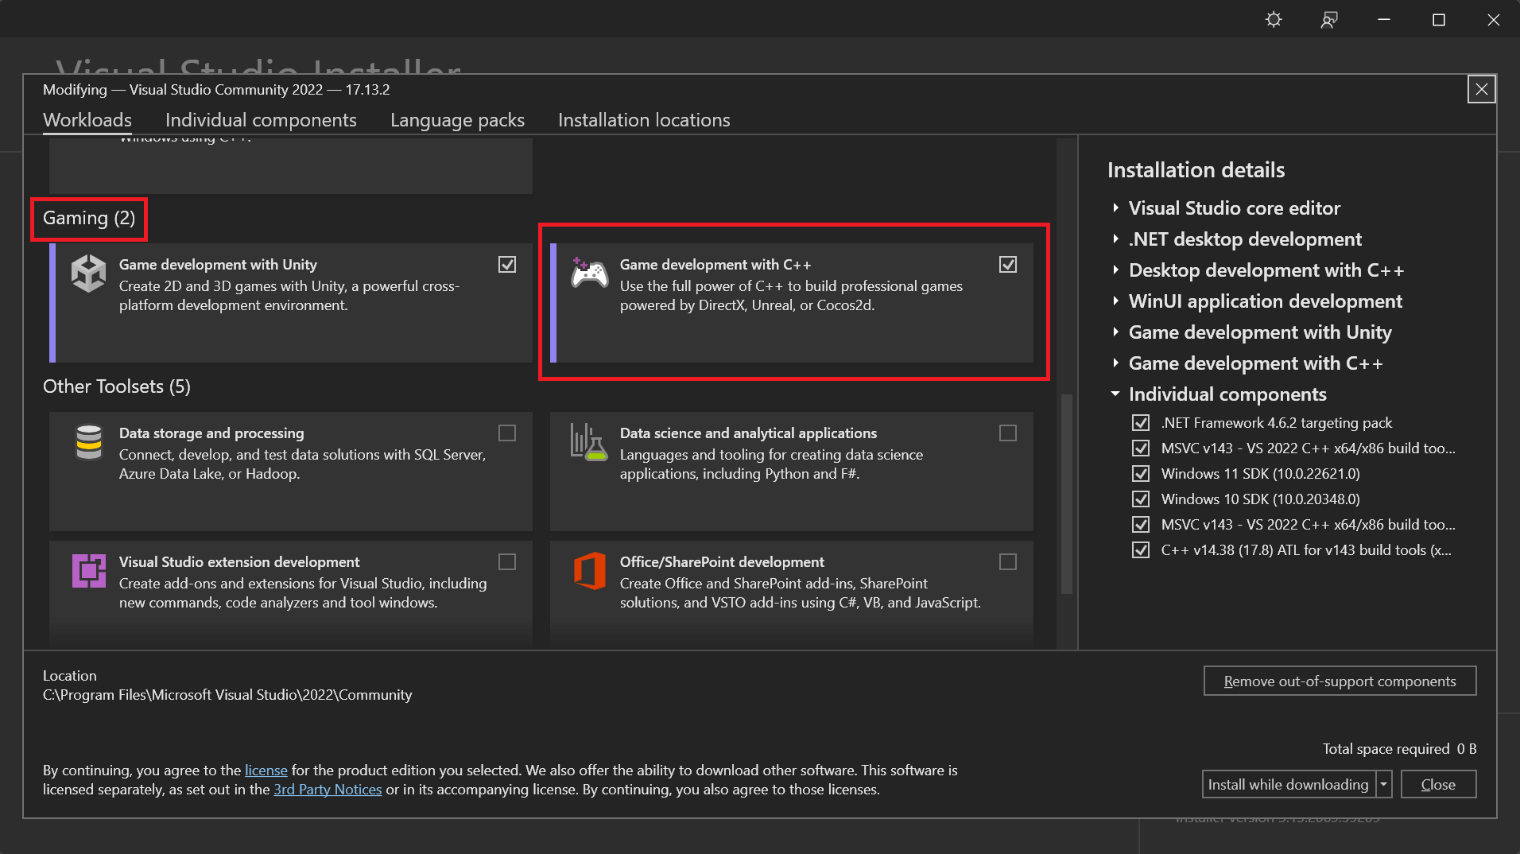
While not mandatory, installing the Unity workload can be beneficial. In the event of an unexpected engine switch, this will allow for a smoother transition.
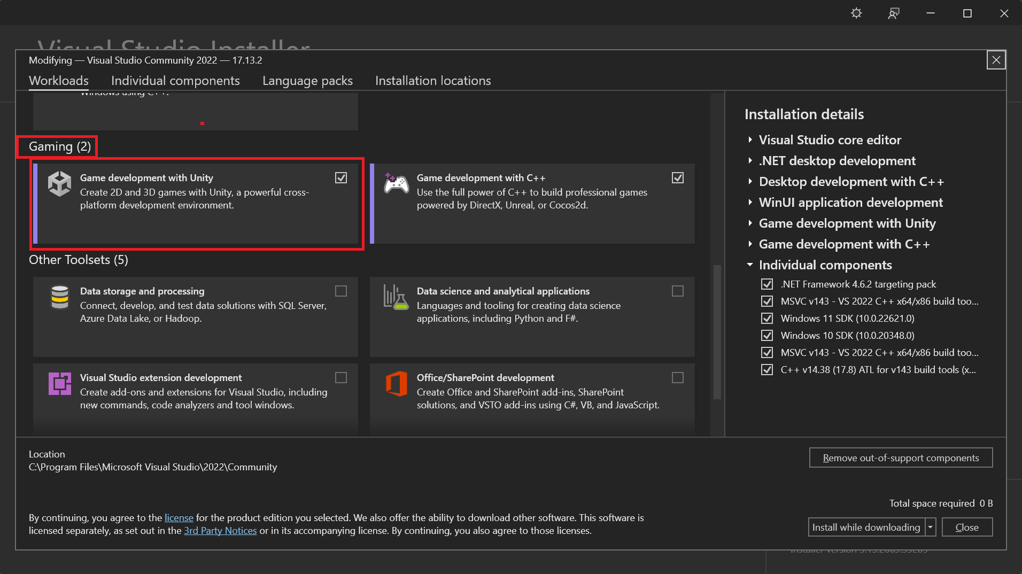
After selecting the required modules, click the Install button.
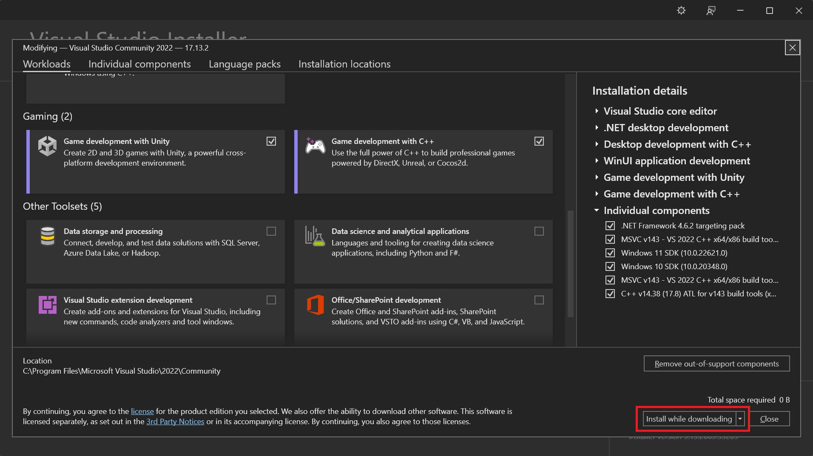
If Visual Studio is already installed but a required component is missing, it can be added as follows:
- Locate the Visual Studio Installer application.
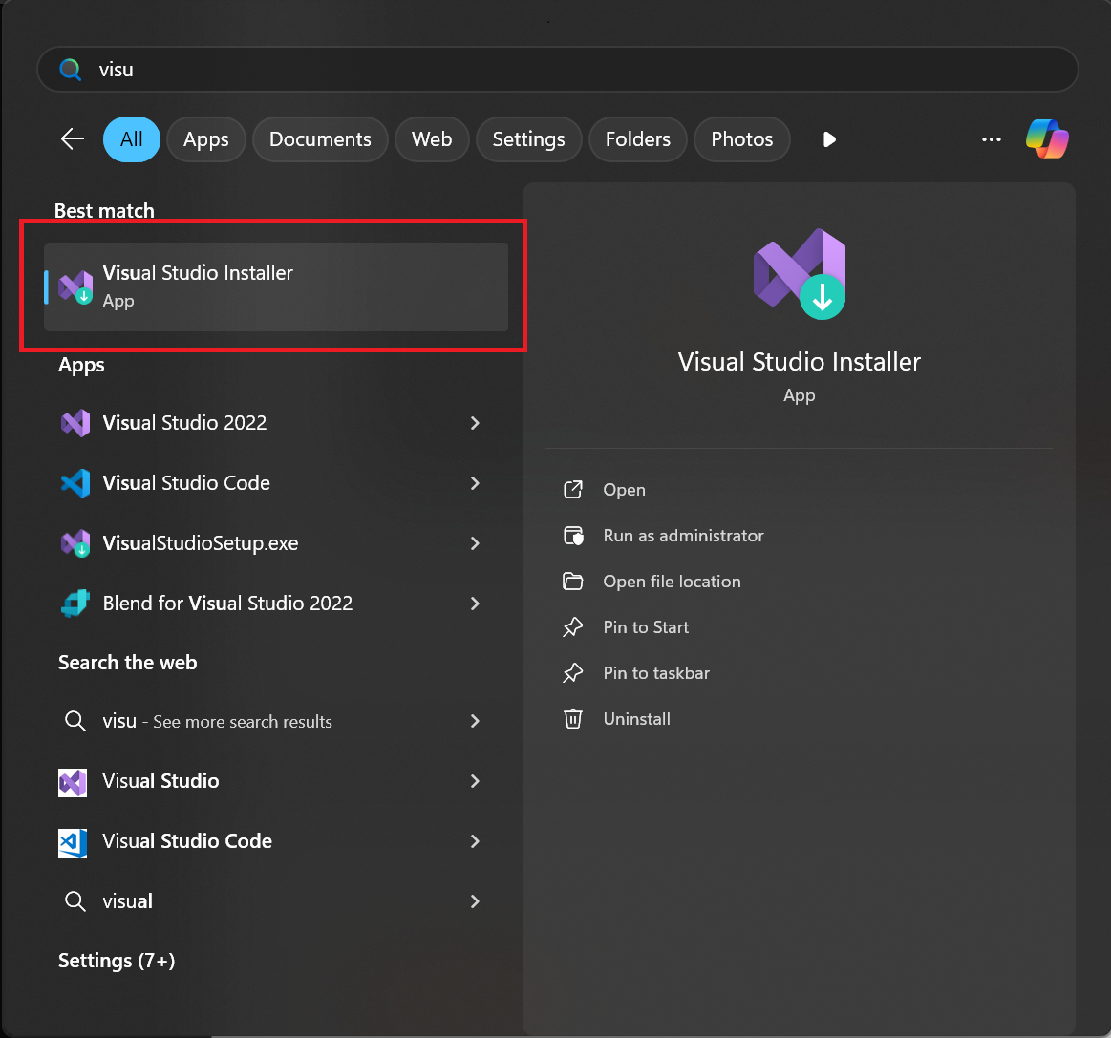
- Click the Modify button.
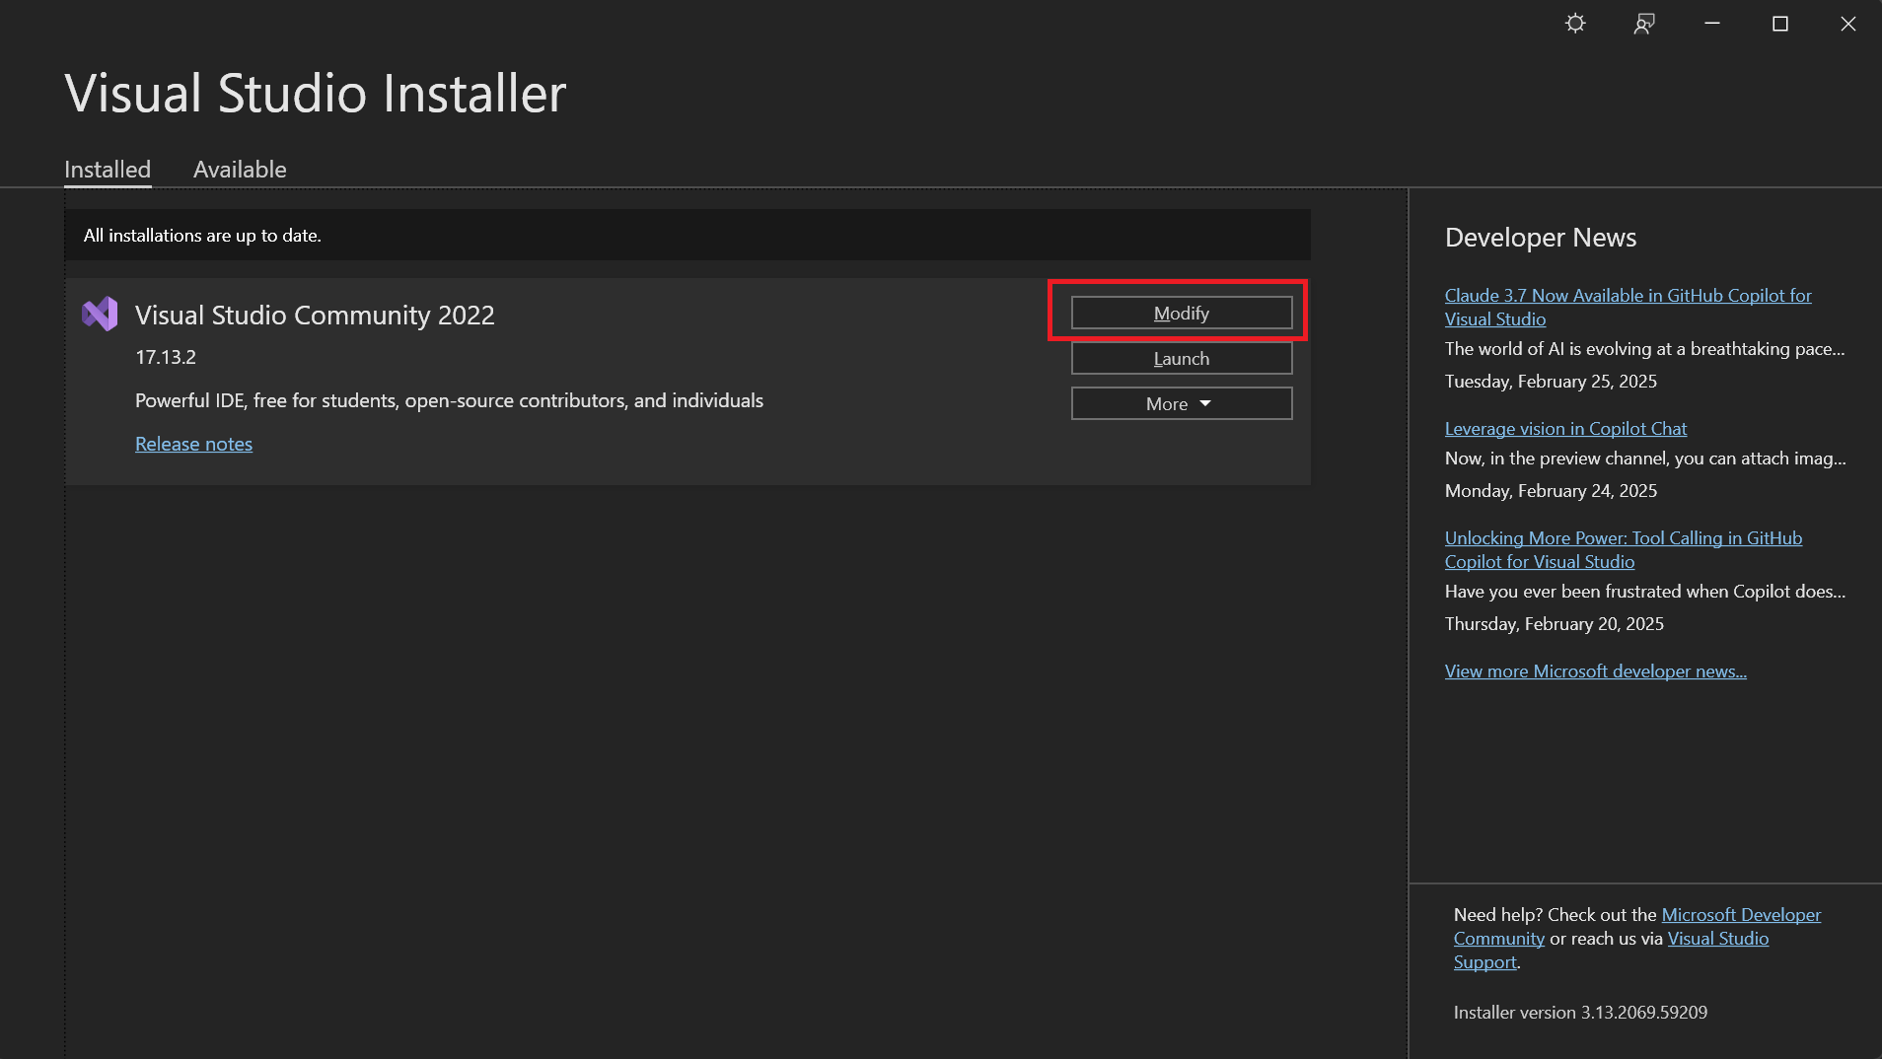
- Select and install the required component.
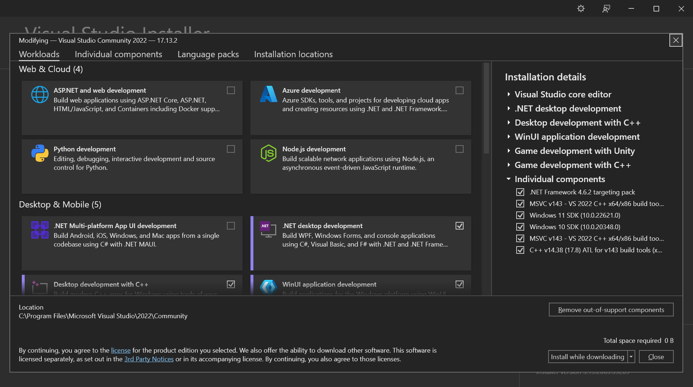

Individual components
In addition to the mandatory modules, it is essential to have the following standalone components installed:
- C++ profiling tools
- C++ AddressSanitizer
- Windows 10 SDK (10.0.18362 or Newer)
These components can be found under the Individual components tab. Use the search bar to filter the results.
If a component is already checked, no further action is needed - it is already installed.
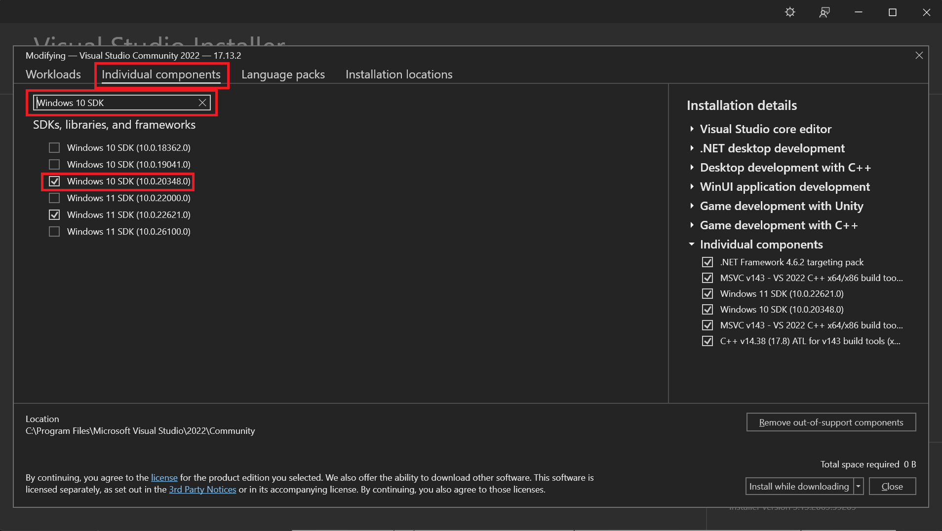

Recommended Settings
By clicking the links below, you can apply the Epic Games-recommended settings in Visual Studio. As developers, each team member can individually decide whether these modifications are necessary.

Links
Recommended settings: https://dev.epicgames.com/documentation/en-us/unreal-engine/setting-up-visual-studio-development-environment-for-cplusplus-projects-in-unreal-engine#recommendedsettings
UnrealVS extension: https://dev.epicgames.com/documentation/en-us/unreal-engine/using-the-unrealvs-extension-for-unreal-engine-cplusplus-projects
Tips and tricks: https://dev.epicgames.com/documentation/en-us/unreal-engine/visual-studio-tips-and-tricks-in-unreal-engine#fixingtheconfigurationcomboboxwidth

Rider
In addition to Visual Studio, we can use Rider IDE, developed by JetBrains, as it is also compatible with Unreal Engine. However, it is important to note that Rider relies on Visual Studio's toolset, making its installation essential for proper functionality.
At the time of writing this document, we are using version 2024.3.6 (Build: 243.25659.34).

Links
Direct installer file: https://www.jetbrains.com/rider/download/#section=windows
JetBrains Toolbox App: https://www.jetbrains.com/toolbox-app/

Installation
Installation from .exe file:
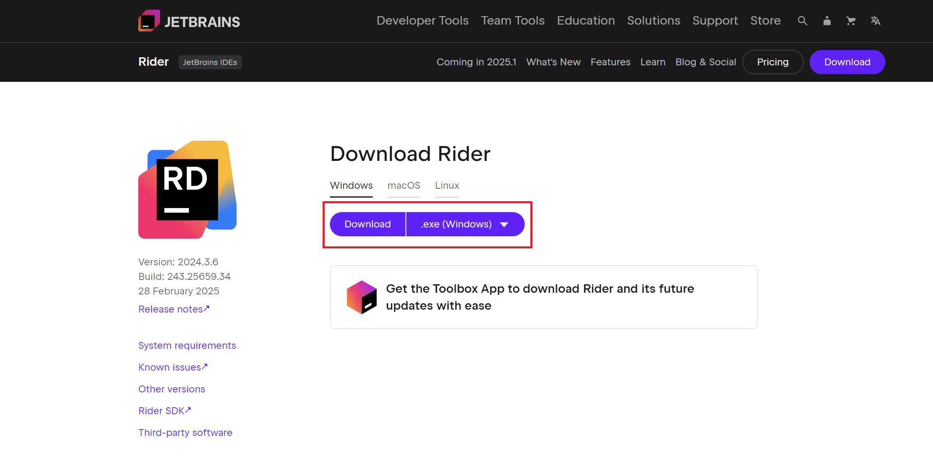
For greater flexibility, it is advisable to install the JetBrains Toolbox App, which allows for the convenient installation, updating, and modification of Rider, as well as the installation of other JetBrains software.
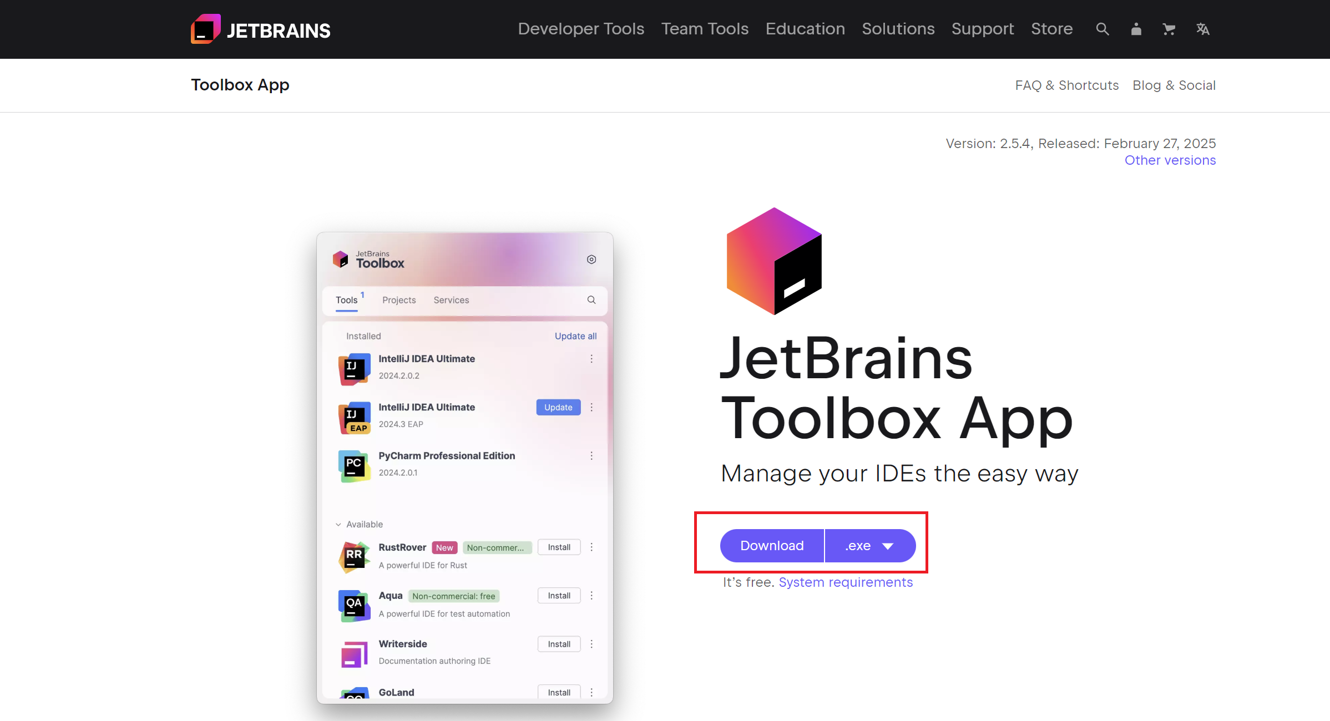
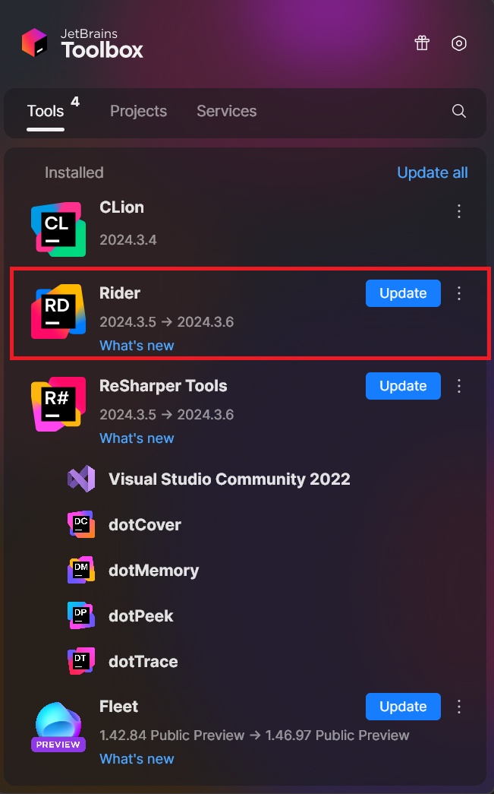

Perforce

Excluding Trees
The following process demonstrates how to exclude a Tree from the Depot. In this case, we will use the rustborn folder as an example.
- Click on Edit Current Workspace….
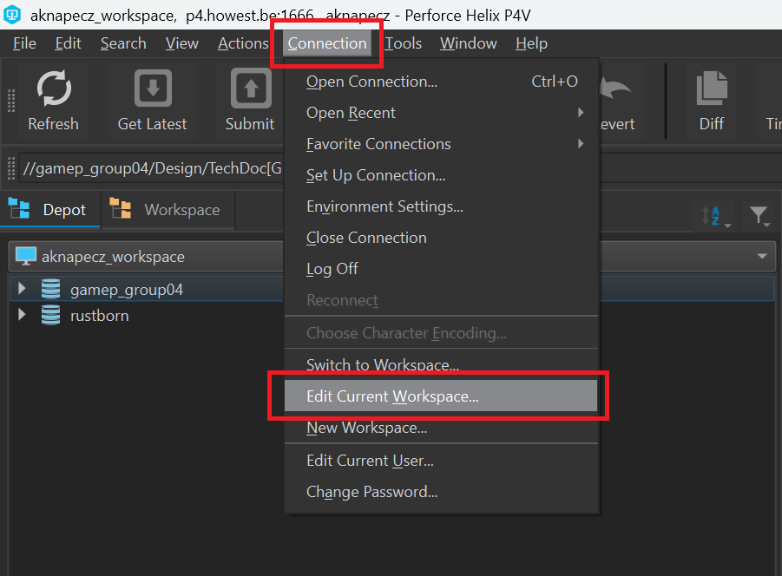
- In the Basic tab, right-click and select Exclude Tree.
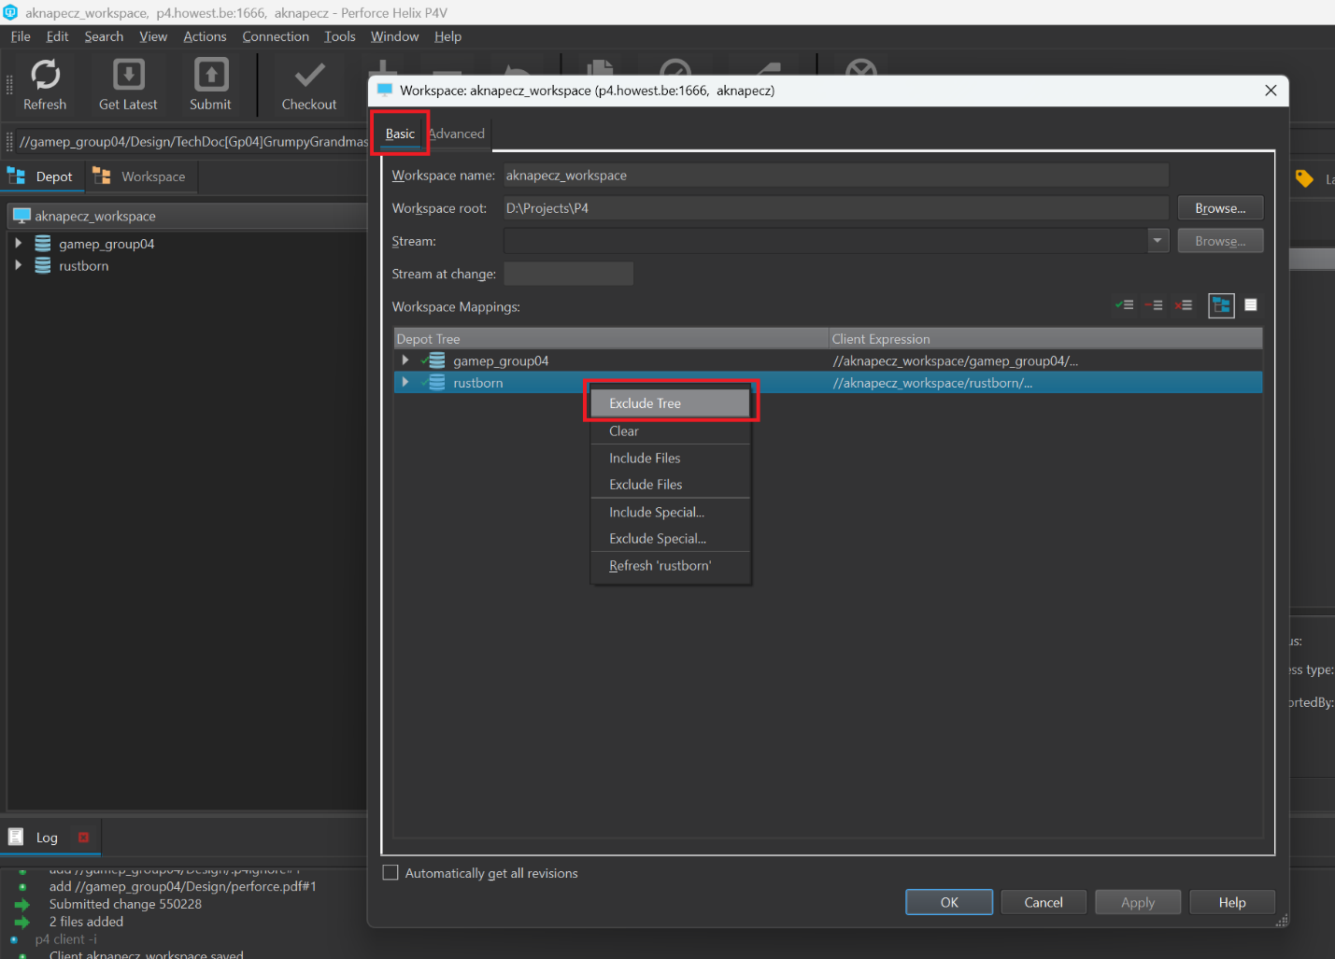
- The icon next to the folder has changed. Click Apply.
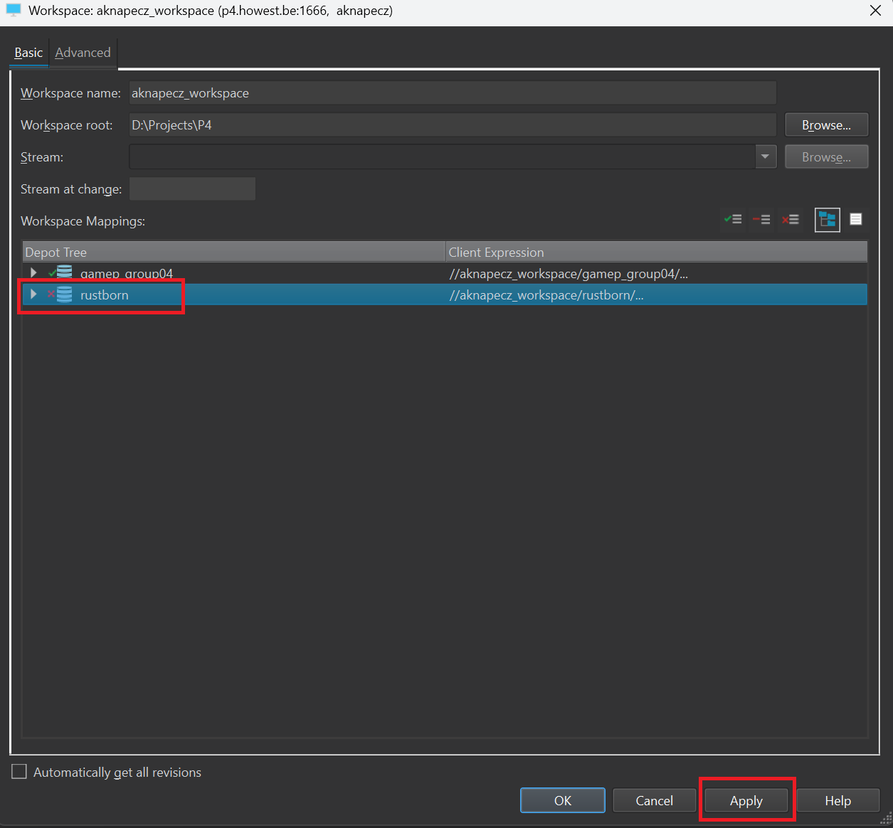
- A pop-up window will appear. Click Update, then close the window by pressing OK.
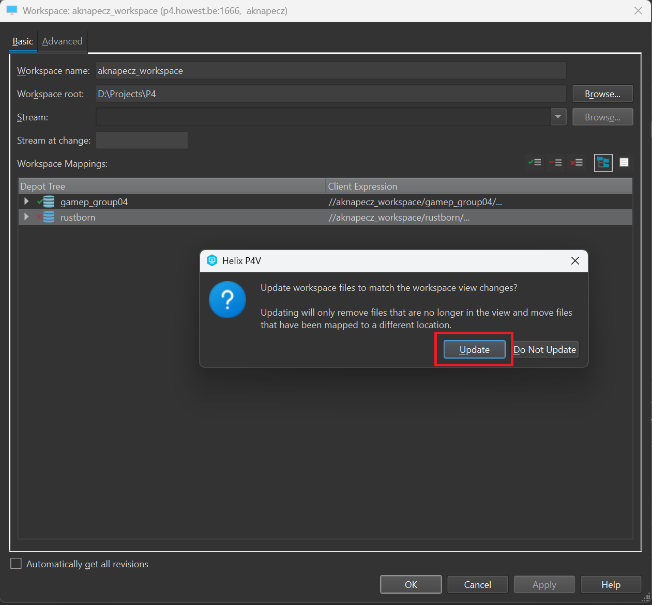
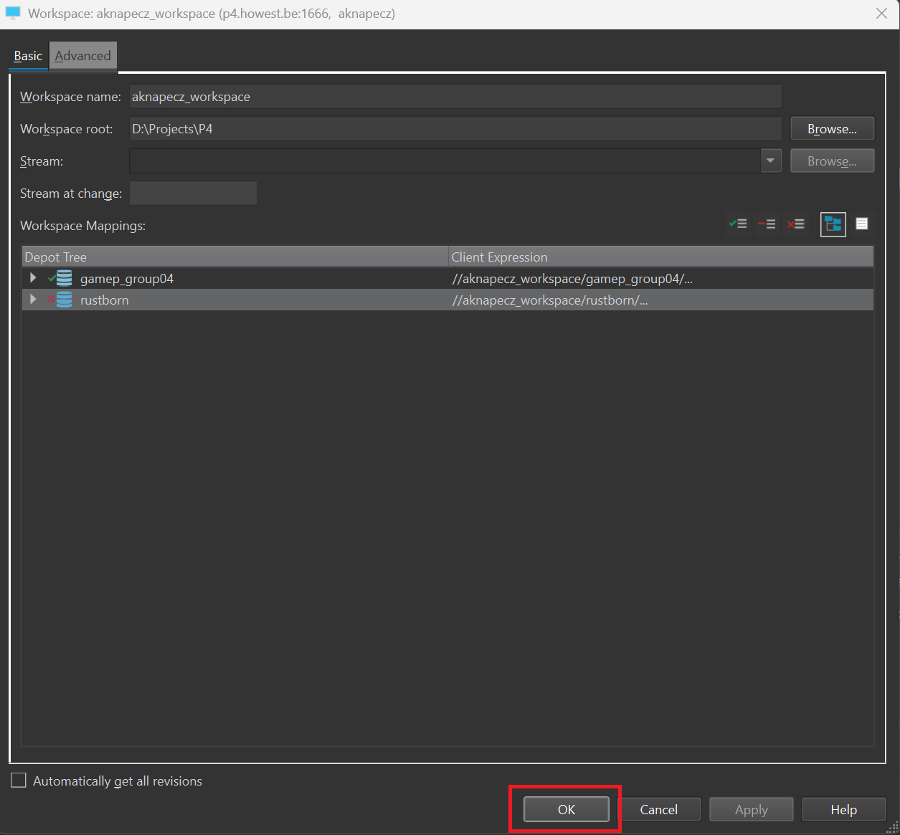
- Verify that the setting was applied successfully. In the Depot tab, click on the rustborn folder and try to download its contents by pressing the Get Latest button. The Log window should display the following message: file(s) not in client view
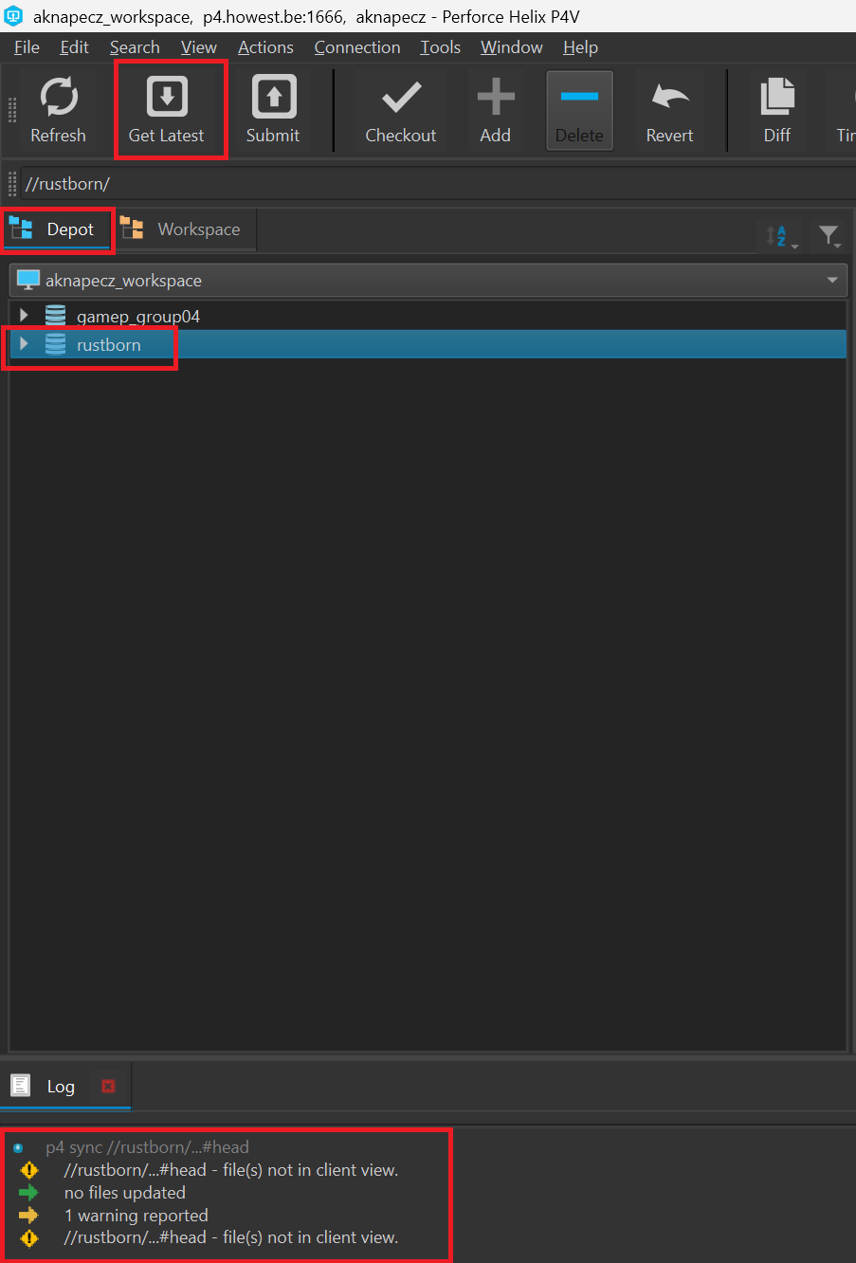

Locking binary documents
If you are working on a document in binary format (.docx), always lock it to prevent merge conflicts. You can lock a file after checking it out.
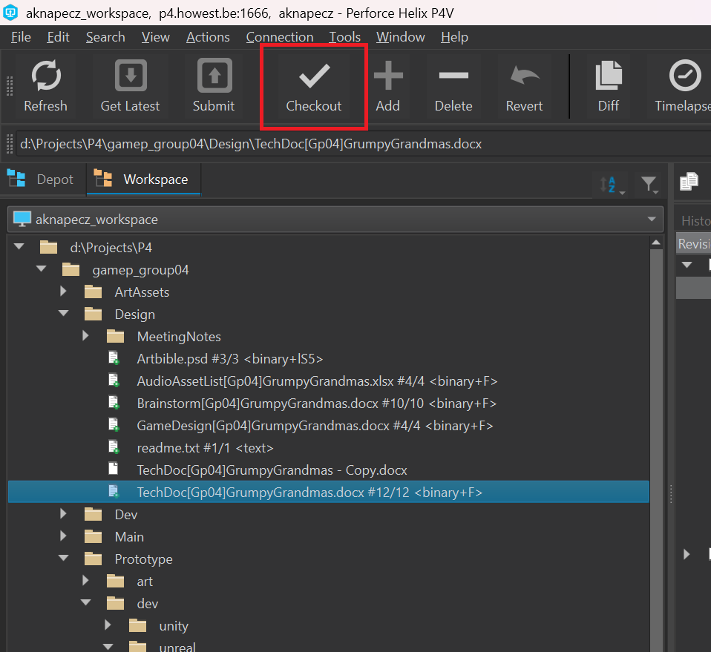
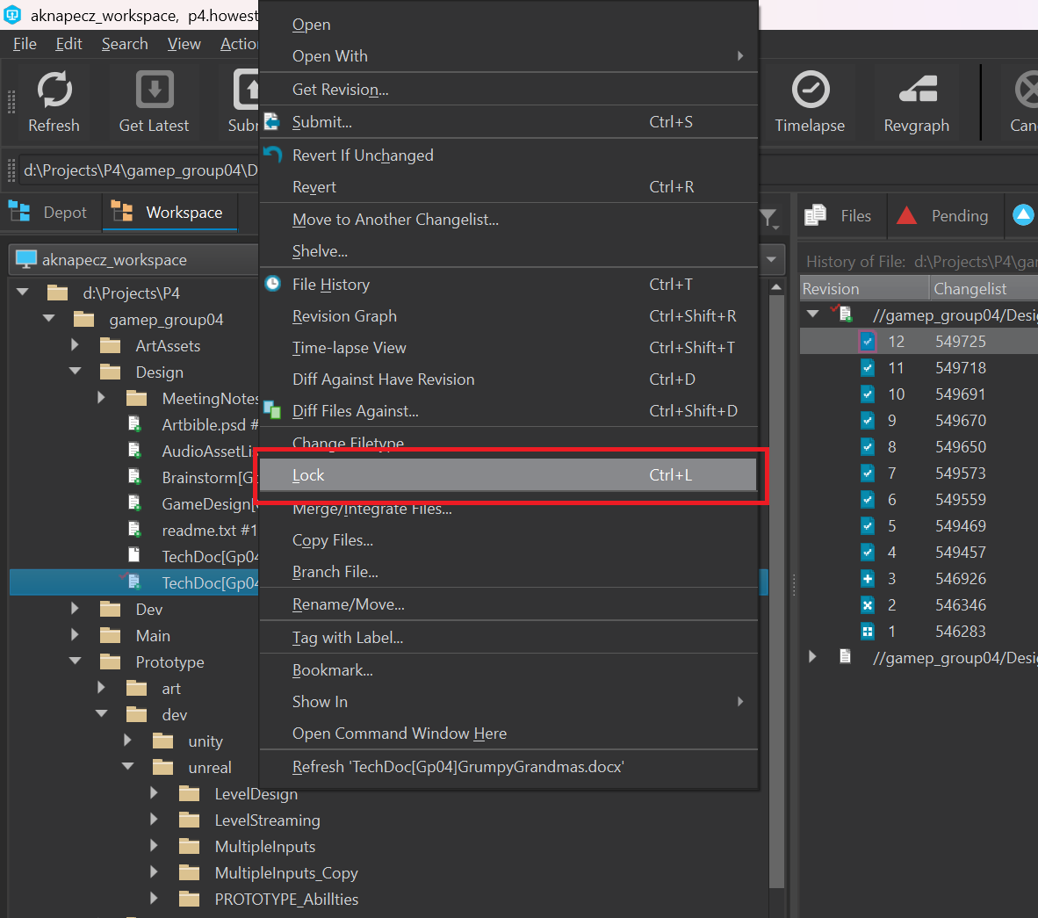
Red question mark indicates merge conflict.
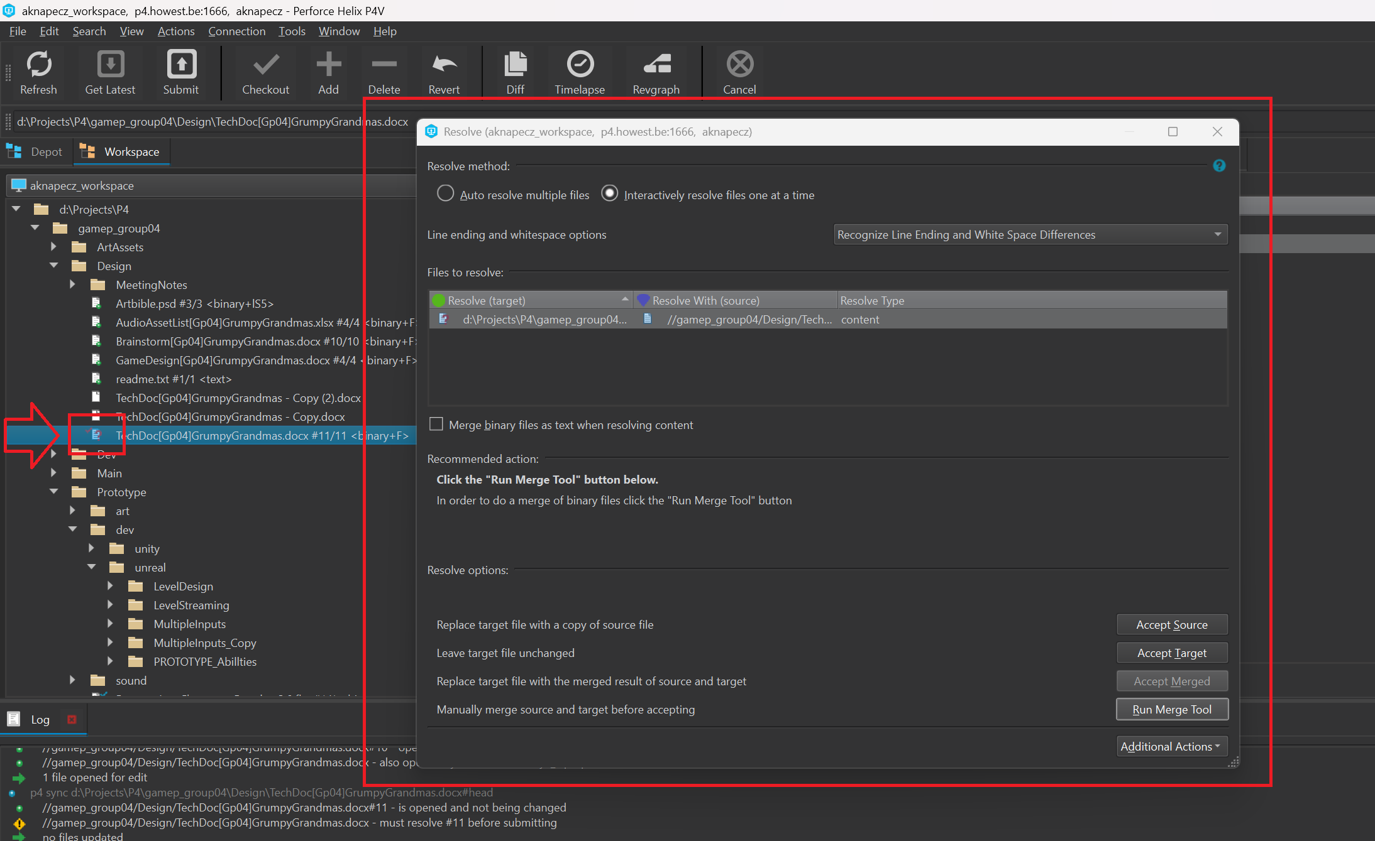

Submitting deleted files
During development, there may be instances where an entire folder or specific files are marked using the Mark for Add... function. Before submitting them to the Depot, certain contents might be deleted. Unfortunately, Perforce lacks the intelligence to track a file's lifecycle, meaning that even after deletion, it remains listed in the Pending tab. If we attempt to submit the entire Pending list, an error will occur, attempting to upload something that no longer exists. In such cases, the Pending list must be manually cleaned.
Within the Pending list, files are displayed in two colors: blue and white. A blue entry indicates an active, existing file.
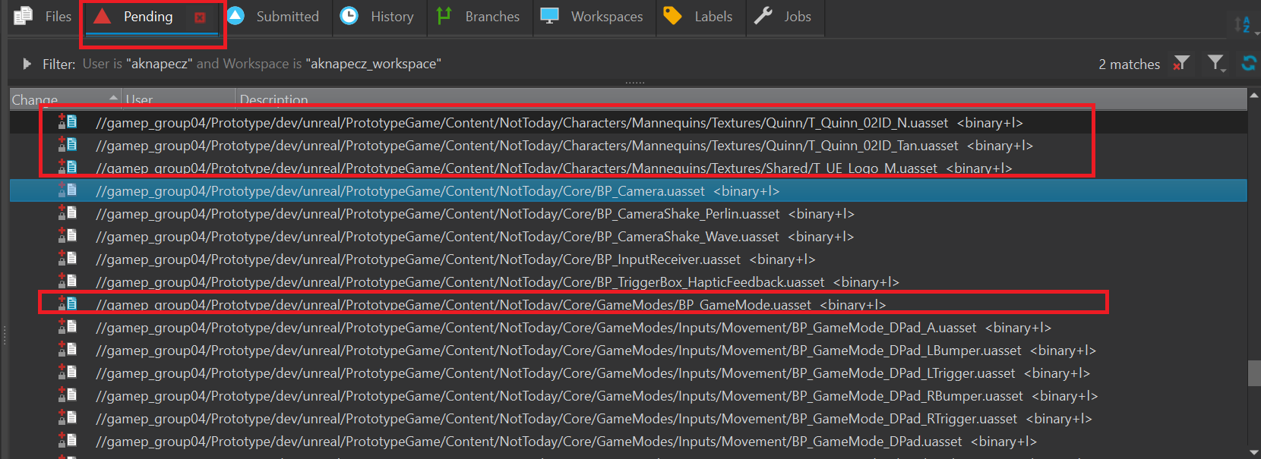
A white entry indicates a deleted or non-existent file.
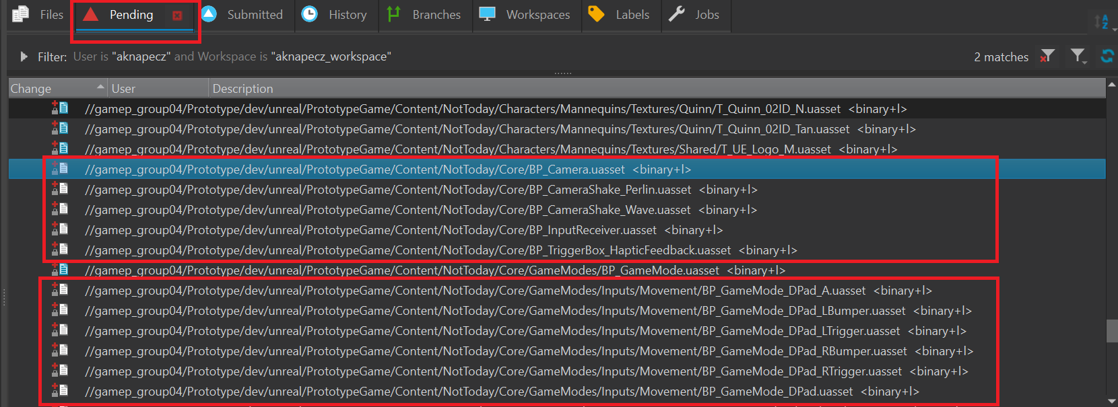
Deleted files can be removed by selecting them and using the Revert option from the right-click menu.
